MINISTRY OF CONSTRUCTION, TRANSPORT AND INFRASTRUCTURE, NEMANJINA 22-26, BELGRADE

Project-level Stakeholder Engagement Plan (Project-level SEP)
LOCAL INFRASTRUCTURE AND INSTITUTIONAL DEVELOPMENT PROJECT
in
Republic of Serbia
December 2021, Final Version
Contents
1 INTRODUCTION 5
1.1 Project Description 5
1.2 Purpose of the Project level Stakeholder Engagement Plan (SEP) 6
1.3 Scope and Structure of the SEP 6
1.4 Administrative and Regulatory Framework 7
1.4.1 National Legislation Requirements 7
1.4.2 World Bank’s Environmental and Social Standard on Stakeholder Engagement (EES10) 8
2 SUMMARY OF PREVIOUS STAKEHOLDER ENGAGEMENT ACTIVITIES 9
3 STAKEHOLDER IDENTIFICATION AND ANALYSIS 9
3.1 Stakeholder Mapping 10
3.1.1 Project Affected Parties 10
3.1.2 Other Interested Parties 10
3.1.3 Disadvantaged or Vulnerable Individuals or Groups 10
3.1.4 Summary of Project Stakeholder Needs and Analysis of their Interest and Influence 11
4 STAKEHOLDER ENGAGEMENT PROGRAM 15
4.1 Purpose and Timing of the Stakeholder Engagement Program 15
4.2 Proposed Strategy of Information Disclosure 16
4.2.1 Preparation 16
4.2.2 Implementation 16
4.2.3 Monitoring 16
4.3 Proposed Strategy for Consultation 17
4.4 Proposed Strategy to Incorporate the Views of Vulnerable Groups 22
4.5 Timelines 22
4.6 Review of Comments 22
4.7 Future Phases of Project 22
4.8 Development of Sub-project Level SEPs (SPSEP) 22
5 RESOURCES AND RESPONSIBILITIES FOR IMPLEMENTING STAKEHOLDER ENGAGEMENT ACTIVITIES 24
5.1 Resources 24
5.2 Management Functions and Responsibilities 24
6 GRIEVANCE MECHANISM 25
6.1 Raising grievances 26
6.2 Grievance administration 26
6.3 Grievance log 27
6.4 Grievance admission and process value chain 27
6.5 Monitoring and reporting on Grievances 28
6.6 World Bank Grievance Redress System 29
7 MONITORING AND REPORTING 29
7.1 Involvement of Stakeholders in Monitoring Activities 30
7.2 Reporting Back to Stakeholder Groups 31
ANNEX 1 32
Grievance Form 32
ANNEX 2 33
Report on public disclosure and public consultation 33

List of Tables
Table 1: Level of stakeholder engagement based on their level of interest and level of influence 14
Table 2: Proposed Strategy of Consultation 19
Table 3. Grievance flowchart 28
Table 4. Monitoring indicators 31

ABBREVIATIONS
E&S | Environmental and Social
ECP | Environmental Commitment Plan
EIA | Environmental Impact Assessment
ESCP | Environmental and Social Commitment Plan
ESF | Environmental and Social Framework
ESIA | Environmental and Social Impact Assessment
ESMF | Environmental and Social Management Framework
ESMP | Environmental and Social Management Plan
ESS | Environmental and Social Standards
RS | Republic of Serbia
GRM | Grievance Redress Mechanism
GRS | Grievance Redress Service
MoF | Ministry of Finance
NGO | Non Governmental organization
OG | Official Gazette
OH&S | Occupational Health and Safety
OIP | Other Interested Parties
PE | Public Enterprise
PIU | Project Implementation Unit
SEP | Stakeholder Engagement Plan
WB | World Bank
SOE | State Owned Enterprise

INTRODUCTION

Project Description
The Government of the Republic of Serbia is making great efforts in its EU path towards green infrastructure and GHG emission reduction by strengthening LGSs capacity to execute municipal funds.
The World Bank (WB) is considering the proposed ‘Serbia Local Infrastructure and Institutional Development Project’ (LIID) that is designed to support the Government of Serbia to increase efficiency, inclusiveness, and sustainability of LSG infrastructure service delivery, i.e. to improve LSGs’ operational performance, financial sustainability and capacity to plan and deliver green and resilient infrastructure service.
This is planned to be implemented through three separate but interlinked components:
Component 1. Rebuilding Better,
Component 2. Strengthening PFM and asset management systems at LSG level, and
Component 3. Project management and capacity building.
Activities under the project are planned to: (1) Support greening of infrastructure, (2) Improve service delivery, (3) Enhance the Policy Framework for Infrastructure Financing, (4) Strengthen PFM and asset management systems, and (5) Establish institutional set up that will enable successful implementation of the project and equipping LSGs with capacities to perform their infrastructure related functions in a sustainable manner.
The LIID project will be implemented across the country, but the scope and exact locations of the interventions are yet to be determined. All works are envisaged to be carried out within the scope of existing infrastructural footprint (with the possibility of minor expansion that can result in land acquisition).
The eligible sub-projects will have to be classified as green per the definition included in the POM and the type of projects anticipated to be financed are: local roads rehabilitation and upgrade to incorporate bike paths, closure of the local roads, and transformation to pedestrian zones and green public spaces, shifting from diesel-run public transport to natural gas or electric, the substitution of old public lighting with EE bulbs, etc. There will be no water supply and wastewater-related projects neither sub-projects related to solid waste disposal.
Direct beneficiary of the LIID project is Ministry of Finance (MoF) and Ministry of Construction, Transport, and Infrastructure (MCTI) as Implementing Agency. Municipalities and local self-governments (LSGs) as end beneficiaries are key stakeholders for subproject implementation, including participating government entities, local SOEs and local communities. Key vulnerable groups include retired, elderly, and people with disabilities and chronic diseases; single-parent headed households, male and female; people with low literacy and ICT knowledge; economically marginalized and disadvantaged groups; persons living below the poverty line; Roma people; Ethnic minorities (e.g. Hungarians) and women. Considering the nature of the Project, strong community, and stakeholder engagement for the proposed activities are the key to Project success. Citizen engagement will be included in the planning stage, providing inputs in infrastructure prioritization. The project will enable participation and promote inclusiveness, especially for vulnerable groups, and ensure that gender considerations are considered.

Purpose of the Project level Stakeholder Engagement Plan (SEP)
The objective of this SEP is to identify different stakeholder groups and provide a strategic framework for their engagement throughout the Project lifecycle. A specific Stakeholder Engagement Plan, that will propose concrete action plans for each project activity will be prepared as soon as details of the activities are available.
It is unlikely that the Program implementation will cause negative impact to potential beneficiaries, including vulnerable groups. It is therefore critical that all potential beneficiaries become aware of the Program, in particular eligibility criteria and application procedures, so that they will not be excluded from the potential benefit.
The SEP thus presents how the PIU plans to communicate with stakeholders who may be affected by or will be interested in the Program throughout its whole life cycle. It also describes a grievance mechanism, which is a process stakeholders may use to raise any concerns about the Project providing their opinions that may influence the Project implementation and its results.
The purpose of the project-level SEP is, therefore, to enhance stakeholder engagement throughout the Project, and lay out a framework which will enable stakeholder engagement in line with the laws of Republic of Serbia, as well as the requirements of World Bank.
In order to meet best practice approaches, the project through implementation of this PSEP and the SEPs will apply the following principles for stakeholder engagement throughout the project cycle:
▪ Openness and life-cycle approach: public consultations for the project(s) will be arranged during the whole life-cycle, carried out in an open manner, free of external manipulation, interference, coercion or intimidation;
▪ Informed participation and feedback: information will be provided to and widely distributed among all stakeholders in an appropriate format; opportunities are provided for communicating stakeholders’ feedback, for analyzing and addressing comments and concerns;
▪ Inclusiveness and sensitivity: stakeholder identification is undertaken to support better communications and build effective relationships. The participation process for the projects is inclusive. All stakeholders at all times encouraged to be involved in the consultation process. Equal access to information is provided to all stakeholders. Sensitivity to stakeholders’ needs is the key principle underlying the selection of engagement methods. Special attention is given to vulnerable groups, in particular women, youth, elderly and the cultural sensitivities of diverse ethnic groups.
Overall, the SEP was developed to: (a) identify and analyze stakeholders including importantly the potential beneficiaries of the Project who may be excluded from or find problems accessing project benefits; (b) lay out a framework for engagement modalities for consultations and disclosure; (c) enable platforms for influencing decisions; (d) define role and responsibilities of different actors in implementing the SEP; and (g) help implement and manage the Grievance Redress Mechanism (GRM).

Scope and Structure of the SEP
This SEP provides general guidance on how to involve the public in all phases of the Project.
The scope of the SEP follows the World Bank’s ESS10. The engagement is planned and will be implemented as an integral part of the Program.
The SEP consists of the following Chapters:
- Introduction
- Summary of Previous Stakeholder Engagement Activities
- Stakeholder Identification and analysis
- Stakeholder Engagement Program
- Resources and Responsibilities for implementing the Stakeholder Engagement Plan
- Grievance Redress Mechanism
- Monitoring and Reporting

Administrative and Regulatory Framework

National Legislation Requirements
Applicable National Framework is as follows:
- The Constitution of the Republic of Serbia (2006): proclaims the rule of law and social justice, principles of civil democracy, human and minority rights and freedoms, and commitment to European principles and values. The Article 74 proclaims the right to healthy environment and grants the right to timely and comprehensive information on the state of the environment.
- The Law on Environmental Protection (“Official Gazette of RS” No 135/2004, 36/2009, 36/2009 – other law, 72/2009 – other law, 43/2011 – CC ruling, 14/2016, 76/2018, 95/2018 – other law and 95/2018 – other law): regulates integral system of environmental protection, defines subjects of the environmental protection system, their authorities and obligations.
- The Law on Environmental Impact Assessment (“Official Gazette of RS” No. 135/2004 and 36/2009): regulates the impact assessment procedure for projects that may have significant impact to the environment, the contents of the Environmental Impact Assessment (EIA) Study, the participation of authorities and organizations concerned, the public participation, trans-boundary exchange of information for projects that may have significant impact on the environment of another country, supervision and other issues of relevance to impact assessment.
- Law on Free Access to Information of Public Importance ("Official Gazette RS" No. 120/04): states that governmental agencies, social associations and officials are required to provide each person with the possibility of receiving and becoming acquainted with documents of public interest, except in cases anticipated by law. This Law regulates the rights to access information of public importance held by public authority bodies, with the purpose of the fulfillment and protection of the public interest to know and attain a free democratic order and an open society. By virtue of this Law access to information shall be granted to all stakeholders, including every natural person or legal entity upon written request unless otherwise regulated by the Law. Within 15 days of receipt of a request at the latest, the authority shall inform the applicant whether the requested information is held, and grant him/her access to the document containing the requested information or issue or send to the applicant a copy of the document, as the case may be.
- The Law on Public Information and Media ("Official Gazette of RS", No. 83/2014, 58/2015 and 12/2016 - authentic interpretation): stipulates that public information is free and is not subject to censorship, that the public has the right and the interest to be informed on issues of public interest, that monopoly in the media is not allowed, that information on the media is public.
- The Republic of Serbia ratified the Aarhus Convention on Access to information, public participation in decision-making and access to justice in environmental matters and it links environmental and human rights and is based on the belief that it is a basic right of present and future generations to live in an environment adequate to health and wellbeing. The convention is focused on achieving this through the implementation of three pillars: rights of access to information, access to decision-making, and access to justice.
Other stakeholder engagement, disclosure and transparency requirements within certain topics and sectors are embedded in the applicable laws regulating each of the treated subject. They are broadly compliant to the requirements of ESS10 but have certain shortcomings when it comes to active outreach and continuous engagement strategies.

World Bank’s Environmental and Social Standard on Stakeholder Engagement (EES10)
The World Bank’s ESS 10, “Stakeholder Engagement and Information Disclosure”, recognizes “the importance of open and transparent engagement between the Borrower and project stakeholders as an essential element of good international practice”. Specifically, the ESS10 requires the following:
- “Borrowers will engage with stakeholders throughout the project life cycle, commencing such engagement as early as possible in the project development process and in a timeframe that enables meaningful consultations with stakeholders on project design. The nature, scope and frequency of stakeholder engagement will be proportionate to the nature and scale of the project and its potential risks and impacts.
- Borrowers will engage in meaningful consultations with all stakeholders. Borrowers will provide stakeholders with timely, relevant, understandable, and accessible information, and consult with them in a culturally appropriate manner, which is free of manipulation, interference, coercion, discrimination and intimidation.
- The process of stakeholder engagement will involve the following, as set out in further detail in this ESS: (i) stakeholder identification and analysis; (ii) planning how the engagement with stakeholders will take place; (iii) disclosure of information; (iv) consultation with stakeholders; (v) addressing and responding to grievances; and (vi) reporting to stakeholders.
- The Borrower will maintain and disclose as part of the environmental and social assessment, a documented record of stakeholder engagement, including a description of the stakeholders consulted, a summary of the feedback received and a brief explanation of how the feedback was taken into account, or the reasons why it was not.” (World Bank, 2017: 98).
A Stakeholder Engagement Framework proportionate to the nature and scale of the project and its potential risks and impacts needs to be developed by the Borrower. It has to be disclosed as early as possible, and before project appraisal, and the Borrower needs to seek the views of stakeholders on the SEF, including on the identification of stakeholders and the proposals for future engagement.

SUMMARY OF PREVIOUS STAKEHOLDER ENGAGEMENT ACTIVITIES
The specific nature of the Project required a broad engagement with various project stakeholders with main discussions between the World Bank and the Government, institutional and sector specific institutional Stakeholders. The preparation of the Project was affected by constrains regarding the global COVID-19 pandemic that imposed to travels and face-to-face meetings.
The specific institutional stakeholder engagement activities that have taken place during Project preparation include:
- Numerous discussions and communication exchange between the World Bank and government agencies at the national, regional and local level;
- Review of project preparation status with representatives from the Ministry of Construction, Transport and Infrastructure and including safeguard documentation.
Citizen engagement activities have started during early project preparation. Local Self Governments (LSG), as main beneficiaries of the Project, have been extensively consulted through an online survey to understand their main challenges and difficulties. More than 100 LSGs completed the survey, answering questions about different topics, such as infrastructure management, governance, public spaces, finance ect., enabling, the Project to better understand their needs and thus, prioritize project activities.
This initial SEP was developed and disclosed prior to project appraisal, as the starting point of an iterative process to develop a more comprehensive stakeholder engagement strategy and plan. It will be updated periodically as necessary, with more detail provided in the first update planned after project approval which is expected to take place within 1 month after the project Effective date.

STAKEHOLDER IDENTIFICATION AND ANALYSIS
The WB ESS 10 recognizes three broad categories of stakeholders:
- Project Affected Parties;
- Other Interested Parties; and
- Disadvantaged / Vulnerable Individuals or Groups.
Project Affected Parties (PAPs) includes those likely to be affected by the project because of actual impacts or potential risks to their physical environment, health, security, cultural practices, well-being, or livelihoods. These stakeholders may include individuals or groups, including local communities. They are the individuals or households most likely to observe/feel changes from environmental and social impacts of the project.
The term Other Interested Parties (OIPs) refers to individuals, groups, or organizations with an interest in the project due to the project location, its characteristics, its impacts, or matters related to public interest e.g. regulators, government officials, the private sector, the scientific community, academics, unions, women’s organizations, other civil society organizations and cultural groups.
It is particularly important to understand project impacts and whether they may disproportionately fall on disadvantaged or vulnerable individuals or groups, who often do not have a voice to express their concerns or understand the impacts of a project.

Stakeholder Mapping

Project Affected Parties
The Project Affected Parties for the Serbia Local Infrastructure and Institutional Development Project include local communities, community members and other parties that may be subject to direct impacts from the Project, as follows:
- People affected by land acquisition
- People living in affected communities
- Citizens/users of infrastructure service delivery
- Vulnerable groups
- Local Self-Governments
- Ministry of Construction, Transport and Infrastructure (MCTI)
- PIU at the Ministry of Construction, Transport and Infrastructure (MCTI)
The sub-project specific SEPs to be prepared at later stages will expand the list of projects affected parties and include for each sub-project those likely adversely impacted by the project activities. These may also include parties affected by beneficial impacts, but the focus of engagement shall lie on drivers of the adverse impacts.

Other Interested Parties
Other Interested Parties for the Serbia Local Infrastructure and Institutional Development Project are as follows:
- Government of the Republic of Serbia
- Ministry of Finance
- The World Bank
- Public Enterprise ‘Roads of Serbia’
- Service providers
- Government inspectorates/ labor, construction, etc.
- Academic institutions
- CSOs
- NGOs
- Standing Conference of Towns and Municipalities
- Media
Those associations that represent potential beneficiaries will be notified about the Program and request them to disseminate Program information broadly among their constituencies. Communication campaign will be conducted at the Program launch through various channels of mass media also to inform potential beneficiaries of the Program.

Disadvantaged or Vulnerable Individuals or Groups
This Project level SEP ensures that disadvantaged or vulnerable individuals or groups, relevant to the project, are identified, that their particular sensitivities, concerns and barriers to project information are assessed and that they fully understand project activities and benefits and participate in consultation processes. The vulnerability may stem from person’s origin, gender, age, health condition, economic deficiency and financial insecurity, disadvantaged status in the community (e.g. minorities or fringe groups), dependence on other individuals or natural resources, etc. Engagement with the vulnerable groups and individuals often requires the application of specific measures and assistance aimed at the facilitation of their participation in the project-related decision making so that their awareness of and input to the overall process are commensurate to those of the other stakeholders.
Since the LIID Project is being implemented across the country, and the details of locations and subproject activities are still to be identified, the exact number of people within detected vulnerable groups is not known at this stage but will be given in detail in sub-project level SEP. However, the project is not expected to have a major negative impact on vulnerable or excluded groups and will arrange, given by sub-project level SEP, for proactive engagement with vulnerable groups in order to ensure as much as possible that their needs are met.
Marginalized and poorest will be targeted and outreached within each local government. In urban areas usually poorest segments of the population are concentrated spatially, usually, they live in the areas underserved with infrastructure service. Thus, targeting the poorest within a local government would be done through efforts to outreach underserved areas within local governments.
Key vulnerable groups include:
- retired, elderly, and people with disabilities and chronic disease;
- single-parent-headed households, male and female;
- people with low literacy and ICT knowledge;
- economically marginalized and disadvantaged groups;
- persons living below the poverty line;
- and women.
In order to minimize and mitigate any potential negative impacts on such groups, the Project will facilitate a proactive engagement with vulnerable individuals or groups to ensure, as much as possible, that their needs are met. The drivers of vulnerability will be in details assessed and identified during development of the sub-project specific SEPs.
The project’s community engagement activity will mainstream the engagement of vulnerable groups, and ensure that they benefit from the project. The stakeholder engagement activities will start during the early preparation of the Project and continue throughout the Project’s lifecycle. The project will be used to strengthen the capacity of the local government in the dialogue with the communities in local road network maintenance.
All activities that will facilitate proactive engagement of disadvantaged or vulnerable groups will be detailed in sub-project specific SEP, since at this stage of the Project exact vulnerable groups are still not known.

Summary of Project Stakeholder Needs and Analysis of their Interest and Influence
The level of stakeholder engagement will depend on stakeholders Interest in the Program and their Influence over it.
As defined by Guidance for writing an effective SEP based on the ESS10 SEP template, the following influence/interest matrix is used to assess the level of stakeholder engagement:

Level of Influence
High | Involve/engage | Involve/Engage | Partner
Medium | Inform | Consult | Consult
Low | Inform | Inform | Consult
 | Low | Medium | High | Level of Interest

Color-coding | Engage closely and influence actively:  require regular and frequent engagement, typically face-to-face and several times per year, including written and verbal information
Keep informed and satisfied:
require regular engagement (e.g. every half-a-year), typically through written information
Monitor:
require infrequent engagement (e.g. once a year), typically through indirect written information (e.g. mass media).

Table 1. provides an overview of the proposed stakeholder engagement based on their level of interest and level of influence.

Table 1: Level of stakeholder engagement based on their level of interest and level of influence
Stakeholder group | Stakeholder | Nature of interest | Level of interest | Level of influence | Level of engagement
Project affected parties | People affected by land acquisition | Interest in project impact on their livelihoods and understanding the compensation procedure and additional support and assistance in restoration of living standards | High | Medium | Consult
 | People living in affected communities | Concerns about community health and safety, traffic construction related impacts (noise, dust, damages, emissions, vibrations) | High | Medium | Consult
 | Citizens/users of infrastructure service delivery | Interest in timely implementation of the project and its impact to improved service delivery | High | Low | Inform
 | Local Self-Governments | As end beneficiaries LSGs have high expectations on timely implementation of the Project to obtain benefit from economic development, lower costs and time savings, safety, environmental benefits in terms of reduced GHG emissions, and possibly other positive externalities. | High | High | Partner
 | The Ministry of Construction, Transport, and Infrastructure (MCTI) | Main counterpart of the WB for Project implementation and permitting authority | High | High | Partner
 | PIU at MCTI | Project management and implementation, oversight, reporting, financial, environmental, and social risk management, grievance management, SEP implementation and coordination | High | High | Partner
Other interested parties | The Ministry of Finance | Loan Agreement oversight | High | High | Partner
 | The World Bank | Interested in achievement of Project Development Objectives and compliance to E&S Standards of the Project | High | High | Partner
 | Public Enterprise ‘Roads of Serbia’ | Responsible authority for maintenance, construction/reconstruction, development, and management of public roads (I and II category) – if applicable, i.e. if any of subprojects include reconstruction/rehabilitation of I and/or II category roads | Medium | High | Involve
 | Various Government Inspections such as Labor, Construction etc. | Interested in enforcement of legal requirements in all aspects of project implementation with emphasis during construction activities. | High | Medium | Consult
 | Service providers / National and international contractors and engineering consultancies | Interested in participating in various bidding procedures | High | Medium | Consult
 | Academic institutions | Interest in project design and implementation / The project may provide a knowledge sharing platform | Medium | Low | Inform
 | CSOs / NGOs | Interested in project benefits and potential environmental and social as well as community health and safety impacts/risks | High | Low | Consult
 | Standing Conference of Towns and Municipalities | Dissemination of Project results and best practices to other LSGs in Serbia | Medium | Low | Inform
 | Media | Enables wide and regular dissemination of information related to the Project, ensures its visibility and facilitates stakeholder engagement | Medium | Low | Inform
Vulnerable individuals or groups | Retired, elderly, and people with disabilities and chronic disease; single-parent-headed households, male and female; people with low literacy and ICT knowledge; economically marginalized and disadvantaged groups; persons living below the poverty line; and women. | Interested in accessibility, affordability of project investments and how the project will affect them | High | Medium | Consult

Each sub-project SEP will need to review the list of stakeholders and verify if there is a need to expand the list and engage with other stakeholders at critical points during Project implementation but mandatory during preparation of respective subprojects. This will be done by checking the following:
- Is our current list focused on relevant stakeholders who are important to our current and future efforts? If no, the Project needs to expand the stakeholder list.
- Do we have a good understanding of where stakeholders are coming from, what they may want, whether they would be interested in engaging with the Project, and why? If no, needs assessment should be reviewed and stakeholder list revised.
- Does the current engagement strategy adequately covers vulnerable groups? If no, the stakeholder list should be revised as well as admission and evaluation criteria.
A potential update will be part of the Monitoring & Evaluation (M&E) segment of the Project.

STAKEHOLDER ENGAGEMENT PROGRAM

Purpose and Timing of the Stakeholder Engagement Program
The purpose of the stakeholder engagement program is to inform, disclose and consult on various project documents and activities early on to establish a dialogue with Project Stakeholders from project planning though implementation and operation.
Various stakeholder engagement activities are proposed to ensure awareness and meaningful consultations about Project activities. The outreach and stakeholder engagement will be gender appropriate, taking into consideration the after-hour chores of women. Targeted messaging will encourage the participation of vulnerable groups, those living in areas affected by the Project, and highlight Project characteristics that are designed to respond to their needs and increase their access to Project benefits.
Project outreach methods. At the beginning of the Project, PIU will organize project launch meetings in each of locations where the sub-projects are identified. The PIU will rely on the support from the respective municipalities/LSGs to help organize community meetings/sensitization sessions in all settlements throughout the Project’s lifecycle. Launch meetings shall be the first step in the sub-project preparatory activities. The Project will include targeted outreach to women and vulnerable groups ahead of these meetings to ensure their integration in the engagement activities.
Social media communication. The PIU shall engage a social specialist who shall be responsible to assist the PIU in disclosure, dissemination of information and communication with the local population. The media for communication shall be as seen fit for each community taking into consideration the type and sensitivity of stakeholders.
Communication Materials. Written information will be disclosed to the public via a variety of communication materials including brochures, flyers, posters, etc. PIU will also update its website regularly (at least on a quarterly basis) with key Project updates and reports on the Project’s environmental and social performance both in English and Serbian. The website will also provide information about the grievance mechanism for the project (Chapter 6).
Information desks. The PIU will set up at affected municipalities Information Desks, in the premises of each affected municipality where they can meet and share information about the project with PAPs and other stakeholders. Information Desks will provide residents with information on stakeholder engagement activities, construction updates, contact details of the PIU. Brochures and flyers on various project related social and environmental issues will be made available at these Information Desks.
Citizen/PAP Perception Survey and Feedback. Six months after each launch meeting the PIU will conduct sample-based stakeholder satisfaction surveys to collect feedback on following:
- Engagement process and the quality and effectiveness of methods
- Level of inclusiveness in the engagement process,
- Quality of the communication and dialogue with the internal stakeholders (PIU, Contractors, GM etc.) during construction works.
The survey results will be soliciting feedback on the effectiveness of the project activities that will be used for communication level improvements. This will allow the PIU to identify potential design issues related to access and implementation of the matching grant program and the effectiveness of advisory services. The survey data will be disaggregated by age, gender and location. Survey results with proposed corrective measures will be published on PIU’s website and discussed at consultation meetings.
Trainings and Workshops. Trainings on a variety of social and environmental issues will be provided to each contractor staff and possibly relevant local government stakeholder. Issues covered will include a sensitization to gender-based violence risks.

Proposed Strategy of Information Disclosure

Preparation
Drafts of all ESF documents (i.e. ESMF, ESCP and SEP) will be publicly disclosed at least 15 days before Public Consultations on the websites of the implementing agency / MCTI https://www.mgsi.gov.rs/ and WB. The disclosure packages will include:
- Project announcement including:
- Brief description of Project
- Description of public consultation arrangements (time, place…)
- Ways of submitting comments and feedback
- Key deadlines
- The respective draft ESF documents
The public disclosure of the draft documents and the Project will be announced through Radio, TV, written and electronic media as well as all available official social media accounts and web pages of the Government and Implementing agency, as part of the overall Stakeholder Engagement activities described above.
The comments on all disclosed data and ESF documents will be reviewed immediately upon arrival by the PIU E&S specialists. Major comment will be incorporated in the final version of the ESF documents and disclosed, together with a report on the feedback, i.e. (i) list of media the announcement was disclosed, (ii) content of the announcement, (iii) time of publishing, (iv) list of received feedback.

Implementation
Site specific management instruments developed to manage environmental and social risk and impacts such as Environmental and Social Management Plans (ESMPs), Resettlement Action Plans (RAP) will be disclosed.
Contractors documents related to management of environmental and social risks (these may include traffic Management Plan, Emergency preparedness and response plans, Codes of Conduct for Employees and Contracted workers etc) shall be made available at Contractors website. Information on timing of project activities and related information shall be made public via various media, newspaper and radio at least 2 weeks prior to actual execution.

Monitoring
During the Project development and construction phase, the Social and Environmental specialist will prepare monthly reports on E&S performance for the PIU and the WB which will include an update on implementation of the stakeholder engagement plan. Monthly reports will be used to develop quarterly reports. The quarterly reports will be disclosed on the Project website and made available at the level of project.

Proposed Strategy for Consultation
Different engagement methods are proposed but driven by the COVID-19 considerations and restrictions the Project will adapt virtual communication and consultation methods considering social distancing requirements. Hence, alternative ways will be adopted in accordance with the local laws, policies and new social norms in effect to mitigate the virus transmission, as well as relevant WHO guidelines and the Banks’ Technical Note: Public Consultations and Stakeholder Engagement in WB-supported operations when there are constraints on conducting public meetings. The alternative approaches to be practiced for stakeholder engagement will include:
- small groups consultations if smaller meetings are permitted, or making reasonable efforts to conduct meetings through online channels (e.g. webex, zoom, skype etc.); Where possible and appropriate, create dedicated online platforms and chatgroups appropriate for the purpose, based on the type and category of stakeholders;
- diversifying means of communication and relying more on social media, chat groups, dedicated online platforms & mobile Apps (e.g. Facebook, Twitter, WhatsApp groups, ViberApp groups, project weblinks/websites etc.);
- employing traditional channels of communications such TV, radio, dedicated phone-lines, SMS broadcasting, public announcements when stakeholders do not have access to online channels or do not use them frequently.
- Chose venues carefully based on hygiene and sanitation standards that can be achieved during the meetings;
- Employ traditional channels of communications (TV, newspaper, radio, dedicated phone-lines, and mail) when stakeholders to do not have access to online channels or do not use them frequently. Traditional channels can also be highly effective in conveying relevant information to stakeholders, and allow them to provide their feedback and suggestions;
- Where direct engagement with project affected people or beneficiaries is necessary, identify channels for direct communication with each affected household via a context specific combination of email messages, mail, online platforms, dedicated phone lines with knowledgeable operators;
Each of the proposed channels of engagement should clearly specify how feedback and suggestions can be provided by stakeholders.
Proposed strategy for consultation is provided in Table 2.

Table 2: Proposed Strategy of Consultation
Project phase | Stakeholder | Topic | Method | Timeframe | Responsibility
RAP, SEP, LMP and ESMP preparation and implementation; Detailed Design | Project affected parties:  People affected by land acquisition;  People living in affected communities;  Citizens/users of infrastructure service delivery;  Vulnerable groups;  Local Self-Governments. | Project scope and rationale;  Land acquisition process;  Project E&S principles;  Resettlement and livelihood restoration options;  Grievance mechanism process;  Potential labor influx stemming from construction works  Awareness raising on Gender Based Violence (GBV)  Community Health and Safety, Environmental and Social risks (other than resettlement) and mitigation measures  Labor Management Procedures (applicable to the Project) for potential job-seekers  Traffic management plan | Public meetings, trainings/workshops, separate meetings specifically for women and vulnerable groups;  Social Media Communication;  Disclosure of written information / Brochures, posters, flyers, website  Information desks / In municipalities and PIU;  Grievance mechanism  PAP survey –Prior to completion of resettlement | Project launch meetings in municipalities;  Monthly meetings in affected municipalities and villages;  Survey of PAPs in affected villages;  Communication through social media (as needed);  Information desks with brochures/posters in affected municipalities (continuous). | PIU
 | Other Interested Parties (External)  Municipalities  Cadaster offices | Land acquisition process;  Registration of land plots;  Resettlement and livelihood restoration options;  Project scope, rationale and E&S principles;  Grievance mechanism process | Face-to-face meetings;  Joint public/community meetings with PAPs. | Weekly (as needed) | PIU
 | Other Interested Parties (External)  Press and media;  CSOs / NGOs;  Service providers / National and international contractors and engineering consultancies;  Academic institutions;  National Government Ministries;  Other Government Departments from which permissions/clearances are required;  LSGs / relevant departments;  General public, tourists, jobseekers | Land acquisition process;  Grievance mechanism process;  Project scope, rationale and E&S principles | Public meetings, trainings/workshops;  Social Media Communication;  Disclosure of written information / Brochures, posters, flyers, website;  Information desks / In municipalities and PIU;  Grievance mechanism; | Project launch meetings;  Monthly meetings in affected municipalities and villages;  Communication through social media (as needed);  Information desks with brochures /posters in affected municipalities (continuous) | PIU
 | Other Interested Parties (Internal)  Other PIU Staff;  Supervision Consultants;  Contractor, sub-contractors, service providers, suppliers, and their workers | Project information - scope and rationale and E&S principles;  Training on sub-management plans;  Grievance mechanism process | Face-to-face meetings;  Trainings/workshops;  Invitations to public/community meetings | As needed | PIU
CONSTRUCTION/RECONSTRUCTION | Project affected parties:  People affected by land acquisition;  People living in affected communities;  Citizens/users of infrastructure service delivery;  Vulnerable groups;  Local Self-Governments. | Land acquisition process (land registration; compensation rates and methodology; livelihood restoration)  Grievance mechanism process;  Health and safety impacts (Construction-related safety measures);  Employment opportunities;  Environmental concerns;  Gender Based Violence (GBV) awareness-raising.  Emergency preparedness and response  Traffic management plan | Public meetings, trainings/workshops, separate meetings specifically for women and vulnerable; individual outreach to PAPs  Social Media Communication;  Disclosure of written information / Brochures, posters, flyers, website;  Information desks / In municipalities and PIU;  Grievance mechanism;  Citizen/PAP survey - Upon completion of resettlement and/or construction | Monthly/quarterly meetings in all affected municipalities and villages with ongoing construction;  Communication through social media (as needed);  Information desks with brochures/posters in affected municipalities (continuous) | PIU  Supervision consultants;  Contractor/sub-contractors;  GM teams
 | Other Interested Parties (External)  Press and media;  CSOs / NGOs;  Service providers / National and international contractors and engineering consultancies;  Various Government Inspections such as Labor, Construction etc.  Academic institutions;  National Government Ministries;  Other Government Departments from which permissions/clearances are required;  LSGs / relevant departments;  General public, tourists, jobseekers | Project information - scope and rationale and E&S principles;  Coordination activities;  Land acquisition process;  Health and safety impacts;  Employment opportunities;  Environmental concerns;  Grievance mechanism process;  Traffic management plan | Monthly/quarterly meetings in all affected municipalities with ongoing construction and headquarters;  Communication through social media (as needed);  Information desks with brochures /posters in affected municipalities (continuous) | As needed | PIU (Environment & Social specialists)  Land acquisition department of municipalities
 | Other Interested Parties (Internal)  Other PIU Staff;  Supervision Consultants;  Contractor, sub-contractors, service providers, suppliers, and their workers | Project information – scope and rationale and E&S principles;  Training on ESA and other sub-management plans;  Grievance mechanism process. | Face-to-face meetings;  Trainings/workshops;  Invitations to public/community meetings | As needed | PIU  Contractor/sub-contractors;
OPERATION PHASE | Project affected parties:  People living in affected communities;  Citizens/users of infrastructure service delivery;  Vulnerable groups;  Local Self-Governments | Satisfaction with engagement activities and GM;  Grievance mechanism process;  Community health and safety measures during operation; | Public meetings, trainings/workshops, individual outreach to PAPs  Social Media Communication;  Disclosure of written information / Brochures, posters, flyers, website  Information desks / In Municipalities and PIU;  Grievance mechanism  PAP survey / Upon completion of  resettlement | Meetings in affected municipalities and villages (six-monthly);  Survey of citizens/PAPs in affected villages;  Communication through social media (as needed);  Information desks with brochures/posters in affected municipalities (continuous) | PIU
 | Other Interested Parties (External)  Press and media;  CSOs / NGOs;  Service providers / National and international contractors and engineering consultancies;  Various Government Inspections such as Labor, Construction etc.  Academic institutions;  National Government Ministries;  LSGs / relevant departments;  General public, tourists, jobseekers | Grievance mechanism process;  Community health and safety measures during operation; | Mass/Social Media Communication Disclosure of written information  Disclosure of activities on the MCTI website and of relevant LSGs | Communication through social media (as needed); | PIU and MCTI  Public relation team

Proposed Strategy to Incorporate the Views of Vulnerable Groups
The Project will take special measures to ensure that disadvantaged and vulnerable groups have equal opportunity to access information, provide feedback, or submit grievances. The deployment of social specialist will help to ensure proactive outreach to all population groups. Training and awareness raising sessions will be conducted in villages rather than municipal centers to ensure higher participation of targeted population. Focus groups or individual consultation meetings dedicated specifically to vulnerable groups will be conducted to gauge their views and concerns including for Roma communities, households and individual to identify any cumulative vulnerability stemming from their alienation from the society and under integration and the impacts attributable to project also be envisaged as appropriate.

Timelines
Sub-project specific SEPs shall be prepared once the details of sub-projects are known. The implementation timeline is still not set, and details will be part of the disclosure and engagement activities.

Review of Comments
The comments on all disclosed data and ESF documents will be reviewed immediately upon arrival by the PIU E&S specialists. Major comment will be incorporated in the final version of the ESF documents and disclosed, together with a report on the feedback, i.e. (i) list of media the announcement was disclosed, (ii) content of the announcement, (iii) time of publishing, (iv) list of received feedback.

Future Phases of Project
Stakeholders will be kept informed as the project develops, including reporting on project environmental and social performance and implementation of the stakeholder engagement plan and grievance mechanism. Projects should report at least annually to stakeholders, but often will report more frequently during particularly active periods, when the public may experience more impacts or when phases are changing (for example, quarterly reports during construction, then annual reports during implementation).

Development of Sub-project Level SEPs (SPSEP)
This Project level SEP serves as a roadmap for development of sub-project level SEPs (SPSEP) to be prepared for sub-projects as soon as the specific locations, stakeholder groups, and specific type and associated activities and schedule of activities for the sub-project are known. These will propose targeted stakeholder engagement programs which largely depend on the sub-project details, including the footprint, geographic location and timing of the Project activities.
The scope and level of detail of the site specific SEPs should be in line with the nature and scale, potential risks, and impacts of the project and the level of concern in the project.
Development of the SPSEP will be based on a screening to ensure relevant information that may be useful to understand the characteristics of people/communities that will be impacted by the project. This may for instance be: environmental data, census data, socio-economic data (information on income, employment…), gender data etc. and their implications from an environmental and/or social point of view will be explained. The Project description shall be kept targeted and relevant to understand the types of stakeholder groups impacted by the project.
A detailed overview of key issues raised in previous stakeholder engagement activities and how early stakeholder input has influenced project design shall be included in the SPSEPs. Lessons learned on any prior stakeholder engagement activities from past projects or ongoing similar projects shall be considered and described as relevant.
Each SPSEP shall review the list of identified stakeholders and ensure that those (i) that are affected or likely to be affected by the project (project-affected parties); and (ii) may have an interest in the project (other interested parties) are adequately identified. Some groups may be interested in the project because of the sector it is in, and others may wish to have information simply because public finance is being proposed to support the project. Based on the analysis, the SPSEPs should adopt the engagement strategies based on stakeholder needs and analysis of their interest and influence.
The SPSEP should be clear and concise and focus on describing the project and identifying its stakeholders. The focus will be on segregating what the key information will be in public domain, in what languages, and where it will be best accessible to allow inclusive access. The SEP needs to be targeted and should demonstrate a means of engagement that is stakeholder specific, concise yet comprehensive and should explain the opportunities for information access, public consultation, provide a deadline for comments, and explain how people will be notified of new information or have opportunities to provide feedback including how these will be assessed and taken into account.
The SPSEP will expand on the GM identified in this PSEP and identify and advertise local grievance entry points as part of the awareness building campaign. Commitments to releasing routine information on the project’s environmental and social performance, including opportunities for consultation and how grievances will be managed shall be made.
The drivers of vulnerability will be in details assessed and identified during development of sub-projects, building upon the groups identified. The following can help outline an approach to understand the viewpoints of these groups:
- Identify vulnerable or disadvantaged individuals or groups and the limitations they may have in participating and/or in understanding the project information or participating in the consultation process.
- What might prevent these individuals or groups from participating in the planned process? (For example, language differences, lack of transportation to events, accessibility of venues, disability, lack of understanding of a consultation process).
- How do they normally get information about the community, projects, activities?
- Do they have limitations about time of day or location for public consultation?
- What additional support or resources might be needed to enable these people to participate in the consultation process? (Examples are providing translation into a minority language, sign language, large print or Braille information; choosing accessible venues for events; providing transportation for people in remote areas to the nearest meeting; having small, focused meetings where vulnerable stakeholders are more comfortable asking questions or raising concerns.)
- If there are no organizations active in the project area that work with vulnerable groups, such as persons with disability, contact medical providers, who may be more aware of marginalized groups and how best to communicate with them.
- What recent engagement has the project had with vulnerable stakeholders and their representatives?
A summary of stakeholder needs will be identified considering the drivers of vulnerabilities but also other barriers requiring adaptation of the common communication and engagement tools.
The SPSEPs will summarize the main goals of the stakeholder engagement program and the envisaged schedule for the various stakeholder engagement activities: at what stages throughout the project’s life they will take place, with what periodicity, and what decision is being undertaken on which people’s comments and concerns.
The SEPs will briefly describe what information will be disclosed in what formats, and the types of methods that will be used to communicate this information to each of the stakeholder groups. Methods used may vary according to target audience.
A strategy for consultation will be adopted with methods varying according to targeted audience (e.g. interviews surveys, public meetings, participatory methods). A strategy to incorporate the view of vulnerable groups and how the views of vulnerable or disadvantaged groups will be sought will be developed.
Details of what resources will be devoted to managing and implementing the SPSEP and what budget is allocated to ensure implementation including the monitoring and evaluation activities will demonstrate the capacity and commitment to implement the SPSEP and activities thereunder.
The SPSEPs shall be prepared in consultation with stakeholders, cleared by the World Bank and disclosed and consulted on, prior to commencement of civil works, in line with the disclosure and consultation requirements outlined in this Project level SEP.
”In line with the discussion during Project Appraisal the subproject level SEPs will be prepared as a part of the subproject Environmental and Social Impact Assessment (ESMP/ESMP Checklist)”.

RESOURCES AND RESPONSIBILITIES FOR IMPLEMENTING STAKEHOLDER ENGAGEMENT ACTIVITIES

Resources
Detailed budgets will be further specified in the sub-project specific SEPs and may include budget categories listed in table below. The SEPs will make a fair and accurate estimation on the required budget to ensure implementation of the engagement strategies.
Tentative budget categories for effective implementation of stakeholder engagement include:
- Staff salaries (Environmental and Social specialists; travel costs for staff)
- Events (Project/sub-projects launch meetings; focus groups)
- Communication campaigns (Posters, flyers; social media campaigns)
- Trainings and workshops (Training on social/environmental issues for PIU and contractor staff; training on GBV for PIU and contractor staff; communication workshops)
- Beneficiary surveys (Mid-project and end-project perception surveys)
- Grievance mechanism (Constitution of local admission points; GM communication materials)
- Other expenses.

Management Functions and Responsibilities
The PIU will be responsible for planning and implementation of stakeholder engagement activities, as well as other relevant outreach, disclosure and consultation activities, as well as for GRM functioning.
To ensure successful SEF and SEP implementation, the PIU engaged an Environmental and Social Specialists to support the project.

GRIEVANCE MECHANISM
A Project level Grievance Mechanism (GM) shall be established by the MCTI/PIU, consisting of Central Feedback Desk (CFD) administered by the PIU and sub-project specific Local Grievance Admission Desks (LGAD) (collectively referred to as Grievance Mechanism (GM)).
The Central Feedback Desk (CFD) shall be established prior to commencement of any activities under the Project to manage and appropriately answer complaints during its different phases while the LGD shall be effective upon decision on each new Subproject has been taken. CFD shall be responsible for overall grievance administration, while the LGD shall serve as local admission point for uptake of grievances and acknowledgment of grievance receipt through local avenues, established and administered by the local governments (affected municipality) with representatives from the key stakeholders (i.e. PIU representative, municipal representative and representative of the local communities). In addition to the GM, legal remedies available under the national legislation are also available (courts, inspections, administrative authorities etc.).
To ensure GM access, potential beneficiaries, communities, and other stakeholders may submit grievances through channels as outlined below. The GM will provide the opportunity for continued feedback on the Subprojects and resolution of individual grievances during implementation. Procedures related to complaints handling will be posted on the MCTI website to ensure full transparency.
The GM shall serve as both Project level information center and grievance mechanism, available to those affected by implementation of all Project sub-components and be applicable to all Project activities and relevant to all local communities affected by project activities. The GM shall be responsible for receiving and responding to grievances and comments of the following groups:
- A person/legal entity directly affected by the project, potential beneficiaries of the Project,
- A person/legal entity directly affected by the project through land acquisition and resettlement,
- People interested in the project, and
- Residents/communities interested in and/or affected by project activities.
The MCTI/PIU will cooperate with LSGs in joint efforts to establishing functioning GM and informing stakeholders about the GM role and function, the contact persons, admission channels, and the procedures to submit a complaint in the affected areas. Information on the GM will be available:
- On the website of the MCTI (http://www.mgsi.gov.rs/)
- On the notice boards and websites of LMs
- Through social media campaigns.
Although the Project’s Sexual Exploitation and Abuse (SEA)/Sexual Harassment (SH) and Sexual Exploitation and Abuse/Sexual Harassment risk was assessed as low (because of (i) the expected local employment and (ii) expected low number of workers on construction sites) the GM will, on a precautionary base, be enabled to recognize SEA/SH grievances. Such grievances will be managed separately by a trained expert, but will use the same process value chain and timeframes described below (chapter 6.4. Grievance admission and process value chain). The necessary training for the appointed staff member who is to deal with such grievances will be provided.

Raising grievances
Effective grievance administration strongly relies on a set fundamental principle designed to promote the fairness of the process and its outcomes. Any grievance can be brought to the attention of the CFD or LGD anonymously, personally or by telephone or in writing by filling in the grievance form by phone, e-mail, post, fax or personal delivery to the address of the MCTI/PIU which will be known once established. The access points and details on entry points shall be publicized and shall be part of the awareness building once the locations of sub-projects are known and once the PIU has been established.

Grievance administration
Any grievance shall follow the path of the following mandatory steps: receive, assess and assign, acknowledge, investigate, respond, follow up and close out.
Once logged the GM shall conduct a rapid assessment to verify the nature of grievances and determine on the severity. Within 5 days from logging it will acknowledge that the case is registered and provide the complainant with the basic next step information. It will then investigate by trying to understand the issue from the perspective of the complainant and understand what action he/she requires. The GM will investigate by looking into the facts and circumstances interview all parties involved and confer with relevant stakeholders. Once investigated, and depending on the severity and type of grievance, the provisional decision shall be discussed with the complainant in the timeframe of 10 days after logging the grievance. Unilaterally announcement shall be an exception. The final agreement should be specific and issued and grievant informed about the final decision not later than 30 days after the logging of the grievance. Closing out the grievance occurs after the implementation of the resolution has been verified. Even when an agreement is not reached, or the grievance was rejected it is important to document the result, actions and effort put into the resolution, close out the case. If the grievance could not be resolved in amicable endeavor, the grievant can resort to the formal judicial procedures, as made available under the Serbian national legal framework. Logging a grievance with the GM does not preclude or prevent seeking resolution from an official authority, judicial or other at any time (including during the grievance process) provided by the Serbian legal framework.
In case of anonymous grievance, after acknowledgment of the grievance within three days from logging, the CGD will investigate the grievance and within 30 days from logging the grievance, issue final decision that will be disclosed on the website of the MCTI. Closing out the grievance occurs after the implementation of the resolution has been verified.
The CGD shall keep a grievance register log that will have all necessary elements to disaggregate the grievance by gender of the person logging it as well as by type of grievance. The personal data of each Grievant shall be protected under the Data Protection Law. Each grievance will be recorded in the register with the following information at minimum:
- description of grievance,
- date of receipt acknowledgement returned to the complainant,
- description of actions taken (investigation, corrective measures), and
- date of resolution / provision of feedback to the complainant,
- verification of implementation, and
- closure.
In case a grievance cannot be resolved in manner satisfactory to the complainant he/she has the right for an appeal. In such cases the resolution of the grievance will be reviewed by a commission at the level of the implementing agency. The commission will consist of three appointed members that are not directly involved in Project implementation. The commission will acknowledge the receipt of the appeal within 3 days and issue the final decision within 5 days of the receipt of the appeal. The decision of the commission will entail a detailed explanation of the grievance resolution process as well as the explanation of the final decision and guidance on how to proceed if the outcome is still not satisfactory for the complainant.

Grievance log
The role of the GM, in addition to addressing grievances, shall be to keep and store comments/grievances received and keep the Central grievance log administered by the PIU.
The PIU will maintain grievance log to ensure that each complaint has an individual reference number and is appropriately tracked, and recorded actions are completed. When receiving feedback, including grievances, the following is defined:
- Type,
- Category,
- Deadline for resolving the appeal, and
- Agreed action plan.
Each complaint should be assigned with an individual reference number and is appropriately tracked and recorded actions are completed. The log should contain the following information:
- Name of the grievant, location and details of the grievance,
- Date of submission,
- Date when the Grievance Log was uploaded onto the project database,
- Details of corrective action proposed,
- Date when the proposed corrective action was sent to the complainant (if appropriate),
- Date when the grievance was closed out,
- Date when the response was sent to the grievant.

Grievance admission and process value chain
Table 3. Grievance flowchart
STEPS | ACTIONS | DAYS
STEP 1: Submission of grievances | Orally, in writing via suggestion/complaint box, through telephone hotline/mobile, mail, SMS, social media (WhatsApp, Viber, Facebook etc.), email, website, and the LGD. The GRM will also allow anonymous grievances to be raised and addressed. The site specific SEPs shall include details of Grievance entry points and focal points.
STEP 2: Recording of grievance | Classifying the grievances based on the typology of complaints and the complainants in order to provide more efficient response, and providing the initial response immediately if possible. The typology will be based on the characteristics of the complainant (e.g., vulnerable groups, persons with disabilities, people with language barriers, etc.) and also the nature of the complaint
STEP 3: Acknowledgement of grievance |  | 5
STEP 4: Investigate and discuss with Complainant | Gathering information about the grievance to determine its eligibility and to generate a clear picture of the circumstances surrounding the issue under consideration. This process normally includes site visits, document reviews, a meeting with the GM user (if known and willing to engage) and meetings with individuals and/ or entities who can assist with resolving the issue. Reasonable efforts will be taken to address the complaint. If the grievance is vague and not clear enough, the GM is obliged to help and provide counsel and even help in redrafting the submission, in order for the grievance/ to become clear, for purposes of an informed decision by the GM, in the best interests of persons affected by the Project. If the GM is not able to address the issues raised by immediate corrective action, a long-term corrective action will be identified. The decision shall give a clear assessment on the grievance/complaint, clear ruling and recommendations for fair remedy and propose measures to modify future conduct that caused the grievance as well as proposed measures to compensate if mitigation measures cannot remedy the harm or injury. The decision shall be in writing and shall be delivered to the person who filed the grievance as well as to any other person or entity to which the recommendation and measures shall apply or is under obligation by Law. The person who filed the grievance can express his/her personal satisfaction to the outcome of the grievance resolution procedure. Unilateral decision shall be an exception and resolution shall be sought through a dialogue between the GM and the Grievant | 10
STEP 5: Communication of the decision |  | 30
STEP 6: Complainant Response | Either grievance closure or taking further steps/second tier commission if the grievance remains open. Before any closure of complaints/grievances, the GM shall:  - Confirm that the required GM actions have been enforced, that the grievance resolution process has been followed and that a fair decision has been made;  - Organize meeting(s) within 10 days of being contacted by the concerned parties to discuss how to resolve the issue, if not previously conducted;  - Recommend the final decision on the mitigation measure to the complainant/aggrieved party;  - Implement the agreed mitigation measure;  - Update the Grievance Report Form and have it signed by the complainant/aggrieved party;  - Sign the Grievance Report Form and log the updated information of the grievance into the Grievance Registry; and  - Send copies of relevant documents (e.g. completed Grievance Report Form, mitigation measure, minutes of the meetings, if appropriate) to the concerned parties.
The Sub-project specific SEPs shall have details on each Grievance admission points, grievance administration processes, timelines, investigation activities and closure conditions including the 2nd tier resolution instance. Further details on local access details LGD are to be known and disseminated at later stages and shall be part of the awareness raising campaign of the sub-project SEPs.

Monitoring and reporting on Grievances
The CFD will be responsible for:
- Regular acquisition of data, as soon as the grievance is received through LGD serving as local admission points, on the number, substance and status of complaints and uploading them into the single regional database;
- Maintaining the grievance logs on the complaints received at the regional and local level;
- Monitoring outstanding issues and proposing measures to resolve them;
- Disclosing quarterly reports on GM mechanisms:
  - On the website of the MCTI (http://www.mgsi.gov.rs/)
  - On the notice boards and websites of LMs
  - Through social media campaigns.
- Summarizing and analyzing the qualitative data received from the local Grievance Admission points on the number, substance and status of complaints and uploading them into the single project database.
The regular social monitoring reports to the WB shall be submitted through the MCTI/PIU, which shall include a section related to GM which provides updated information on the following:
- Status of GM implementation (procedures, training, public awareness campaigns, budgeting etc.);
- Qualitative data on number of received grievances (applications, suggestions, complaints, requests, positive feedback) and number of resolved grievances;
- Quantitative data on the type of grievances and responses, issues provided and grievances that remain unresolved;
- Level of satisfaction by the measures (response) taken;
- Any corrective measures taken.

World Bank Grievance Redress System
Communities and individuals who believe that they are adversely affected by a World Bank (WB) supported project may submit complaints to existing project-level grievance redress mechanisms or the WB’s Grievance Redress Service (GRS). The GRS ensures that complaints received are promptly reviewed in order to address project-related concerns. Project affected communities and individuals may submit their complaint to the WB’s independent Inspection Panel which determines whether harm occurred, or could occur, as a result of WB non-compliance with its policies and procedures. Complaints may be submitted at any time after concerns have been brought directly to the World Bank’s attention, and Bank Management has been given an opportunity to respond. For information on how to submit complaints to the World Bank’s corporate Grievance Redress Service (GRS), please visit http://www.worldbank.org/en/projects-operations/products-and-services/grievance-redress-service. For information on how to submit complaints to the World Bank Inspection Panel, please visit www.inspectionpanel.org

MONITORING AND REPORTING
The PIU will be responsible for overall compilation of progress and results. Feedback and grievances received through the GRM will be aggregated and included in regular reports. During implementation SEP may be updated based on the identification of new stakeholders and/or the need for different forms of stakeholder engagement.
Monitoring reports documenting the environmental and social performance of the Project during construction will be prepared by the Social and Environmental specialists to be engaged by the PIU for the PIU and the World Bank. These reports will include a section regarding stakeholder engagement and grievance management, based on the proposed set of indicators. Achievement of indicators shall rely on information from the SEL and the Grievance Log.

Table 4. Monitoring indicators
ENGAGEMENT WITH PAPs
Number and location of formal meetings with PAPs
Number and location of informal meetings with PAPs
Number and location of community awareness raising or training meetings
Number and location of formal meetings with PAPs
Number and location of informal meetings with PAPs
Number and location of community awareness raising or training meetings
Number and location of formal meetings with PAPs
ENGAGEMENT WITH OTHER STAKEHOLDERS
Number and nature of engagement activities with other stakeholders, disaggregated by category of stakeholder (Governmental departments, municipalities, NGOs)
Minutes of meetings will be annexed to the six-monthly report
Number and nature of Project documents publicly disclosed
Number and nature of updates of the Project website
Number and categories of comments received on the website
GRIEVANCE RESOLUTION MECHANISM
Number of grievances received, in total and at the local level, on the website, disaggregated by complainant’s gender and means of receipt (telephone, email, discussion)
Number of grievances received from affected people, external stakeholders
Number of grievances which have been (i) opened, (ii) opened for more than 30 days, (iii) those which have been resolved, (iv) closed, and (v) number of responses that satisfied the complainants, during the reporting period disaggregated by category of grievance, gender, age and location of complainant.
Average time of complaint’s resolution process, disaggregated by gender of complainants and categories of complaints
Number of LGD meetings, and outputs of these meetings (minutes of meetings signed by the attendees, including the complainants to be
annexed to the report)
Trends in time and comparison of number, categories, and location of complaints with previous reporting periods
WORKERS GRIEVANCES
Number of grievances raised by workers, disaggregated by gender of workers and worksite
Number of workers grievances (i) opened, (ii) open during more than 30 days, (iii) resolved, (iv) closed, and (v) number of responses that satisfied the workers, during the reporting period disaggregated by category of grievance, gender, age of workers and worksite.
Profile of those who lodge a grievance (gender, age, worksite), by category of grievances.
Average time of complaint’s resolution process, disaggregated by gender of complainants and categories of complaints
Trend in time and comparison of number, categories, and location of complaints with previous reporting periods

Involvement of Stakeholders in Monitoring Activities
The Project provides several opportunities to stakeholders, especially Project Affected Parties to monitor certain aspects of Project performance and provide feedback. LGD at the level of each affected municipality will allow PAPs to submit grievances and other types of feedback. Citizen/PAP surveys at the project mid-point and end stages will also allow PAPs to provide feedback on project performance. Furthermore, frequent and regular community meetings and interactions with PIU staff, will allow PAPs and other local stakeholders to be heard and engaged.

Reporting Back to Stakeholder Groups
Stakeholder comments on the ESF draft document will be reviewed immediately after receipt. In case the comment implies the need for changes, the document will be updated and disclosed along with the reports on feedback.
Other comments and grievances gathered throughout the implementation will be used for the purpose of further tailoring stakeholder engagement activities.

ANNEX 1

Grievance Form
Reference No:
Full Name
Note: you can remain anonymous if you prefer, or request not to disclose your identity to the third parties without your consent. In case of anonymous grievances, the decision will be disclosed at the Projects website https://www.mgsi.gov.rs/
First name _____________________________________
Last name _____________________________________

❏ I wish to raise my grievance anonymously
Gender of complainant (completion of this field is optional)
❏ Male ❏Female ❏Other ___________________ (please indicate)
❏ I request not to disclose my identity without my consent Contact Information Please mark how you wish to be contacted (mail, telephone, e-mail).
❏ By Post: Please provide mailing address: _________________________________________________________________ ________________________________________________________________ __________________________________________
❏ By Telephone: _______________________________________________
❏ By E-mail _______________________________________________
❏ I will follow up on the resolution at the website as I want to remain anonymous
Preferred language for communication ❏ Serbian ❏ Other (indicate)
Description of Incident or Grievance (What happened? Where did it happen? Who did it happen to? What is the result of the problem? Date of Incident/ Grievance)

❏ One-time incident/grievance (date _______________)
❏ Happened more than once (how many times? _____)
❏ On-going (currently experiencing problem) What would you like to see happen to resolve the problem?

Signature: _______________________________ Date: _______________________________

Please return this form to: Ministry for Construction, Transport and Infrastructure / PIU

ANNEX 2

Report on public disclosure and public consultation
As required by WB Environmental and Social Standard 10 (ESS10) – Stakeholder Engagement and Information disclosure, during preparation of Draft ESMF, ESCP, RPF, SEP and LMP documents the Borrower carried out public consultations with relevant stakeholders.
Starting from November 18, 2021, The Ministry of Construction, Transport and Infrastructure, Infrastructure, disclosed the Draft ESMF, ESCP, RPF, SEP and LMP documents on its web sites and announced invitation for Public Consultations for the public, bodies and organizations interested in subject documents prepared for LIID Project. Same announcement was published in the daily newspaper with national coverage “Politika” on November 18, 2021. Public and other interested parties and organizations were invited to participate in process of public consultation on draft ESMF, ESCP, RPF, SEP and LMP documents.
On November 25, 2021, at 12:00 AM (local time), public consultations and presentation of the Draft ESMF, ESCP, RPF, SEP and LMP documents were organized through ZOOM platform, due to pandemic situation. The meeting was attended by a diverse group of 6 stakeholders, namely representatives of MCTI, WB and different local self-governments.
The following persons attended:
1. Tijana Živanović, representative of MCTI
2. Siniša Trkulja, representative of MCTI
3. Igor Miščević, representative of WB
4. Vesna Šabanović, representative of City Belgrade
5. Sanja Cvetković, representative of City Kragujevac
6. Aleksandar Perić, representative of municipality Ljubovija

The consultation consisted of two parts. The first part consisted of general overview of the Environmental and Social Framework (ESF) and the purpose of ESMF, ESCP, RPF, SEP and LMP documents during implementation. In addition, it was emphasized that all activities supported under the Project shall be environmentally and socially sound, sustainable, and consistent with WB ESSs and Serbian national legislation. Project screening procedure and risk classification are explained, as well as legal and administrative framework for Project.
The meeting started according to schedule at 12:00 AM. The Environmental and Social Specialist Mr. Nebojsa Pokimica presented all project documents in details to the interested attendees.
Questions and Answers during public presentation and consultations:
Q1. Comments from representative MCTI, Tijana Zivanovic, was connected with RPF document and Law of housing and needs that same articles of that Law should be mentioned in RPF.
A1. RPF document will be adjusted with comments.
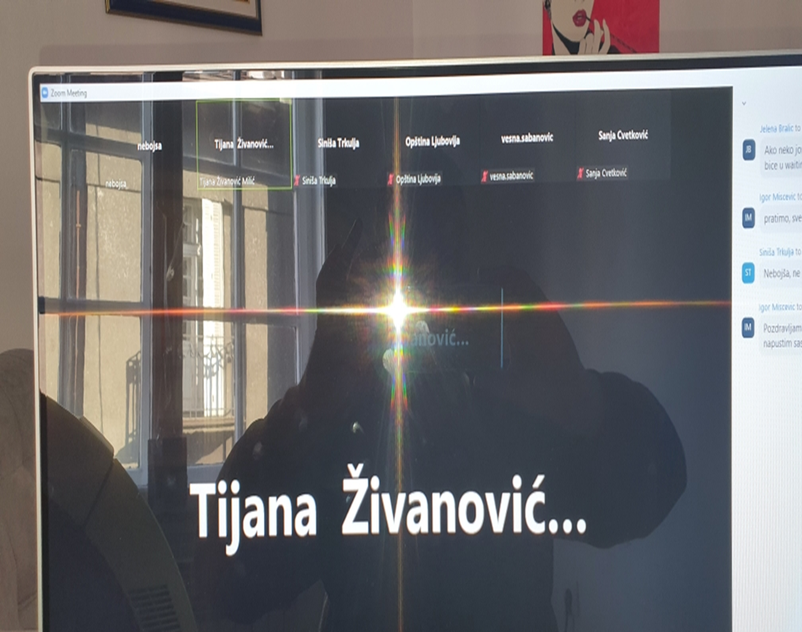

Picture 1 Screenshot of PC during public consultation through Zoom platform

2. ATTENDANCE SHEET
1. Tijana Živanović, representative of MCTI
2. Siniša Trkulja, representative of MCTI
3. Igor Miščević, representative of WB
4. Vesna Šabanović, representative of City Belgrade
5. Sanja Cvetković, representative of City Kragujevac
6. Aleksandar Perić, representative of municipality Ljubovija
3. DOCUMENTATION
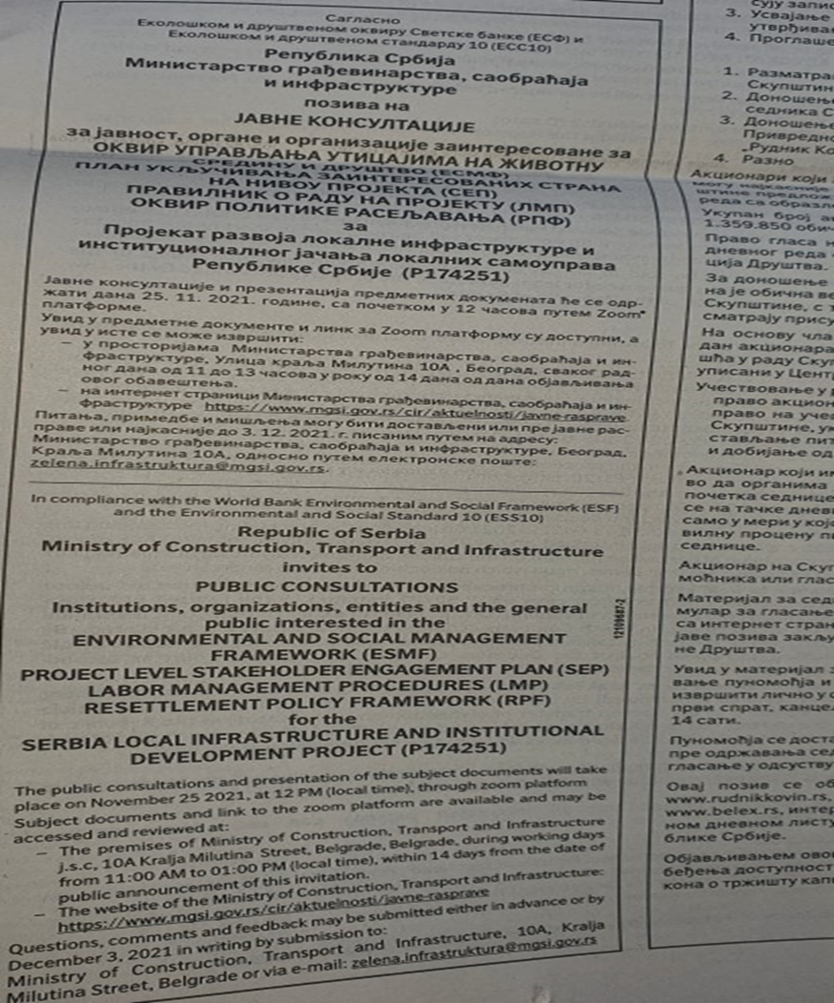
Picture 2 Announcement of public consultation in daily newspaper, (“Politika”, November 18, 2021)

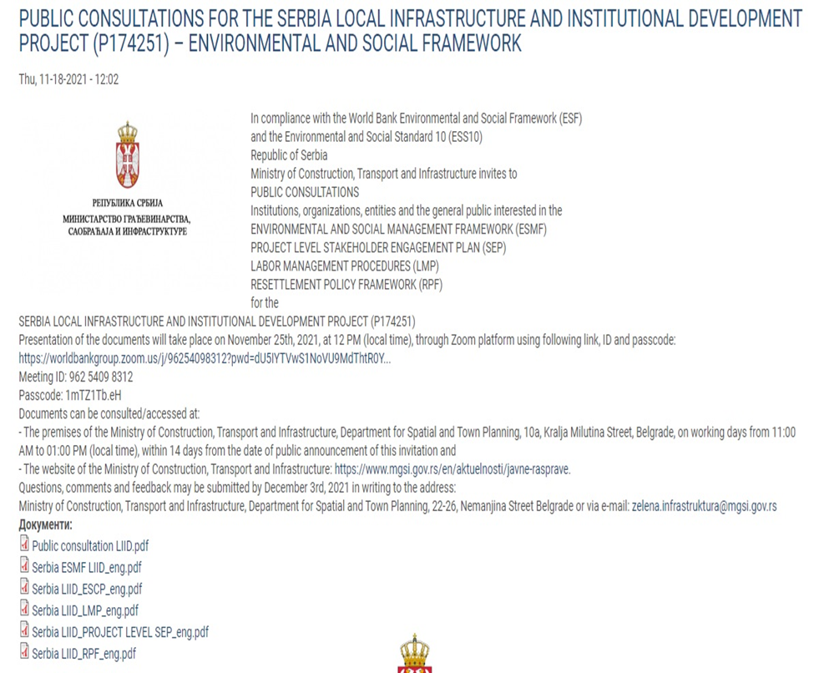
Picture 3 Announcement of public consultation on the MCTI web site on November 18,2021, English

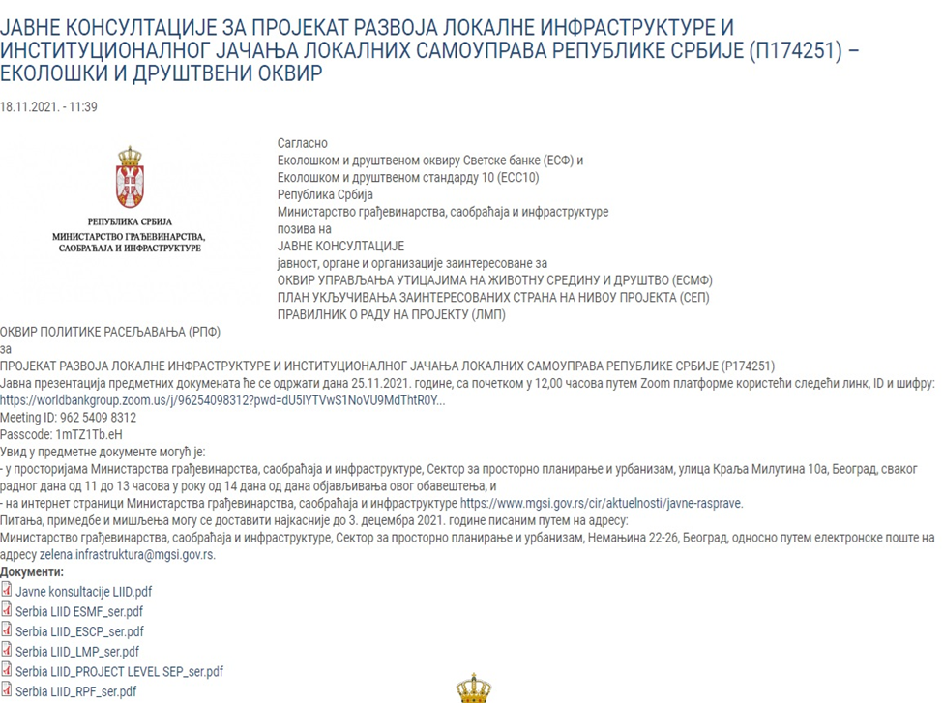

Picture 4 Announcement of public consultation on the MCTI web site on November 18,2021, Serbian

