Republic of Serbia
Ministry of Construction, Transport, and Infrastructure
Nemanjina 22-26, 11000 Belgrade

Serbia Railway Sector Modernization Project
PROJECT GRIEVANCE MECHANISM

This document is published in English and Serbian on the Ministry of Construction, Transport and Infrastructure website.
https://www.mgsi.gov.rs/en/dokumenti-list/89/174

It describes the overall Project Grievance Mechanism which has been established and is already functional for any Project related questions or comments. The document also describes the process of establishing local level and contractor grievance management and as the Project evolves, the specific contact details and locations of grievance management announcements are being added at the end of the document in Chapter 6. Grievance management announcements include user friendly instructions for stakeholders on how a grievance can be submitted using local or central level contact details.

February 2023

Table of Contents
1 Introduction 3
2 Purpose of the Grievance Mechanism 3
3 Grievance Mechanism Principles 5
4 Organization of the GM 6
4.1 Local Grievance Desk 7
4.2 Contractor Grievance Desk 7
4.3 Central Grievance Desk 8
4.4 Second-Degree Appeals Committee of the Ministry 8
5 Processing of Grievances 9
5.1 Processing Steps 9
5.2 Phone Grievances 11
6 Local and Contractor Grievance Desk Details 11
Annex 1 - Grievance Form 12

Introduction

The Government of Serbia is implementing the Railway Sector Modernization Project (the Project) with financial support from the World Bank (WB). A Project Implementation Unit (PIU) has been established within the Ministry of Construction, Transport, and Infrastructure of the Republic of Serbia (the Ministry), in charge of facilitating the implementation of this Project.

The Project comprises three components focusing on the rehabilitation and renewal of existing railway infrastructure and provision of technical assistance for key institutions in the sector. Within the first Project component there are a number of planned activities which involve construction works in various regions and municipalities across Serbia (see Figure 1), where interaction with Project stakeholders is necessary. They include rehabilitation of railway tracks and infrastructure in Belgrade and Pančevo, further construction works on the Prokop station in Belgrade, works on railway level crossings in approx. 138 locations all across Serbia and construction of the Bogojevo station bypass. In addition to construction activities, interaction with stakeholders, to better understand their views and expectations regarding the modernization of Serbian railways, is also expected in relation to a number of other Project activities.

The Project has been developed and will be implemented in accordance with the WB environmental and social policies and standards. One of the requirements defined in WB ESS10, addressed by this document, is to establish and implement a Project Grievance Mechanism (GM), to respond to questions, concerns or grievances of individuals, groups or organizations, who are or could be affected by the Project, or have an interest in the Project.

The GM is not a legal mechanism, and it does not prevent anyone from utilizing legal remedies, administrative or judicial, available under the laws and regulations of the Republic of Serbia.

Purpose of the Grievance Mechanism

The purpose of creating and implementing a Project GM, alongside all other stakeholder engagement methods, is three-fold:
- to effectively provide information on the Project to all interested stakeholders by addressing their concrete questions and requests for information,
- to prevent or address any negative environmental and social Project consequences brought to the attention of the Project through individual complaints, and
- to enable analyses of received grievances, with the aim of guiding future Project implementation and stakeholder engagement activities, to achieve better overall results.

The GM addresses grievances of external Project stakeholders (individuals, groups or organizations) referred to as complainants further in the text. It is not intended for use by employees, staff members, workers, etc. associated with the Project, who are considered internal stakeholders, and for whom a separate internal grievance mechanism has been established by the Project.

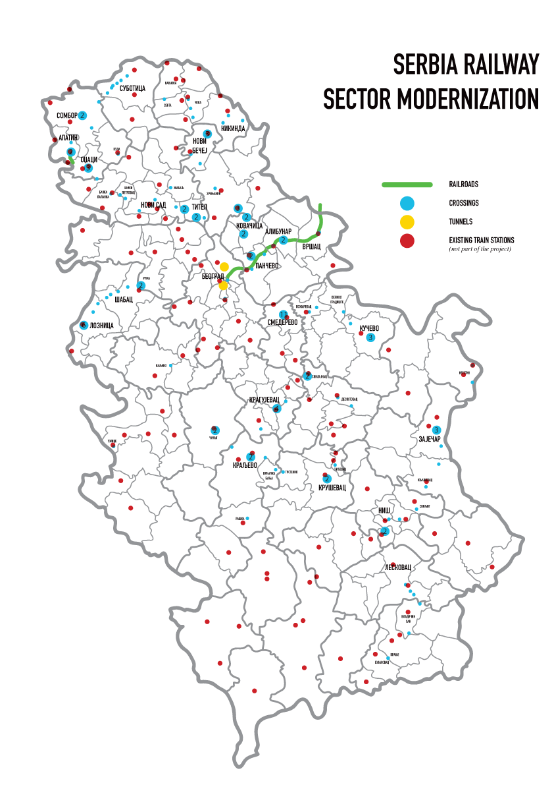
Figure 1: Locations of planned Project construction works

Grievance Mechanism Principles

In developing the GM, the Project has defined certain key principles that it will abide by in the process of addressing grievances, as follows:

- Accessibility and cultural adequacy

The GM is available to any individual, group, or organization affected by or interested in the Project and its use is free of charge. Information about the grievance mechanism is provided in Serbian and is displayed in accessible locations, described further in the document. The information on how to submit grievances will also be provided in other languages in official use in the Republic of Serbia depending on the multi-ethnic composition of communities where the project will be established.

Advice and assistance to file a grievance is provided in written form and verbally, through local and central grievance desks, which also help with explaining the response to the complainant, if needed. Grievances can also be submitted in writing or verbally, through various channels, including post, email, telephone or in person, as preferred by the complainant. Vulnerable persons who may have difficulties to submit a grievance, should be fully assisted in this process.

- Transparency

The GM describes the full procedure of processing a grievance, i.e. all the internal steps taken to consider and address a grievance, as well as who is involved in the decision-making process. It provides a clear overview of what the complainant can expect in the process and how an appeal can be submitted in case the grievance has not been successfully closed in the first instance.

- Timeliness

The GM procedure has been developed with a view of enabling individuals, groups or organizations to approach responsible Project staff quickly, to remedy any urgent issues in connection with the Project. It includes deadlines for certain actions by the Project, including providing a response within a specified time period.

- Non retaliation and respect of privacy

Anyone submitting a grievance is guaranteed that there will be no retaliation against him/her for doing so. In addition, grievances can be submitted anonymously, in which case a response is made available through public channels. Personal details of complainants are never published and are not shared with anyone other than the people involved in the processing of grievances and implementing any corrective measures, only when necessary and upon approval of the complainant.

- Good faith

The GM is designed to promote interaction between the Project and its stakeholders, to engage in dialogue and identify the best solutions for resolving grievances, acceptable to all sides. The GM is a voluntary process, and it does not prevent complainants from taking legal action in accordance with the laws of the Republic of Serbia, nor does it in any way impact legal proceedings and outcomes.

Organization of the GM

Taking into consideration the specific nature of the Project, with overall management at central level supported by a PIU, as well as implementation of certain Project activities in various locations in Serbia, two levels of the grievance management process have been defined. The first is at the local level, which also includes any contractors performing works in the field, and the second refers to the central level grievance management process. In addition, if a certain grievance is not resolved at either of these two levels, an appeal process has been set up, where final decisions are made by a Second-Degree Committee formed by the Decision of the Minister of Construction, Transport, and Infrastructure. The organization of the GM is presented in Figure 2 of this document.

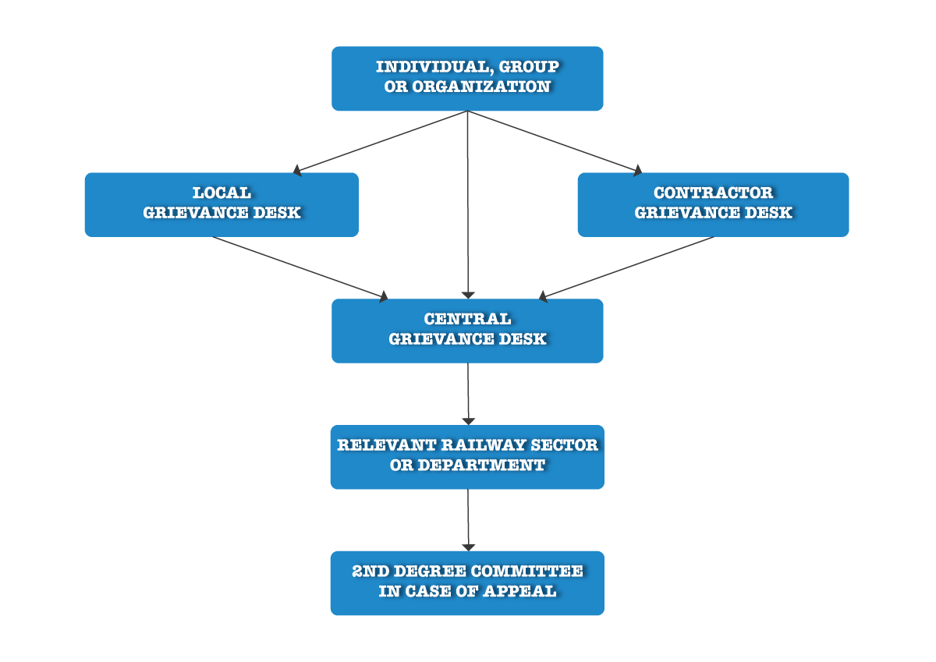

Figure 2 Organization of the Project GM

Local Grievance Desk

The local grievance in the locations where subproject activities are to be implemented. This is to ensure that complainants have easy access to GRM and that any smaller or localized grievances or requests for information can be resolved efficiently. The local grievance desk is set up either for a specific subproject, in the location where this subproject is implemented, or in a specific location, to cover all grievances related to a number of subprojects being implemented in that same location.

The local grievance desk is operated either by an employee of Serbian Railways Infrastructure working in local traffic departments responsible for local railway facilities (e.g. local train station) or a person designated by the local self-government on the territory where activities are implemented. This decision is made on an individual basis, depending on specific sub project circumstances and in cooperation between the Project and local self-governments. Once established, contact details of the person in charge of the local grievance desk (Local Grievance Manager), who is trained for the task by the PIU Central Grievance Manager, will be available all throughout the affected area and posted on the relevant websites, including the Project website and websites of local municipalities. Typical locations where GM announcements are provided include notice boards of the municipalities and any relevant local communities and train stations, but also any other locations for community gatherings such as the local culture center, health care center or pharmacy, local restaurant or shop, etc.

The most up to date list of already established local grievance desks for the Project, with contact details of grievance managers and the locations of grievance announcements is available in Chapter 6 of this document.

Contractor Grievance Desk

It is important to underline that if the Project involves any construction works at the local level, the selected contractor is also required to participate in the GM process by establishing the contractor grievance desk. This is because certain grievances relate directly to the actual construction works being performed in the field, which are under the direct responsibility of the contractor. This means that any selected contractor is obliged to designate at least one employee who is in charge of accepting and processing grievances. The contractor is obliged to inform the Project about all received grievances and how they were approached and handled. There are also situations in which grievances need to be addressed by the contractor and the PIU jointly.

Once the contractor grievance desk is established, which has to be done before any field activities take place, contact details of the person in charge of this desk (Contractor Grievance Manager) will be available alongside the contact details of the Local Grievance Manager, as well as in the location of the actual construction works (e.g. on the entrance gate of the construction site or on the construction board). The local grievance desk and the contractor grievance desk will fully cooperate in dealing with local level grievances and will ensure regular exchange of information, about project related grievances.

The most up to date list of already established contractor grievance desks for the Project, with contact details of grievance managers and the locations of grievance announcements is available in Chapter 6 of this document.

Central Grievance Desk

The central grievance desk is operated at the Project level, to ensure that more complex grievances or requests for information, which require the participation or feedback from various railway sectors and departments, are addressed.

The central grievance desk is operated by the PIU Social and Citizen Engagement Expert, also referred to as the Central Grievance Manager, who reports directly to the Head of the Project PIU, responsible for overall Project implementation. The Central Grievance Manager is in charge of collecting all grievances (resolved and unresolved) from the local and contractor grievance desks in one registry, providing support to these desks to perform their duties, monitoring their performance, responding on grievances and reporting to the PIU and WB. The Central Grievance Manager facilitates the processing of grievances, either submitted directly to the central desk or unresolved by the local/contractor desk, by engaging with all relevant railway sectors and departments and supports the work of the Second-Degree Committee deciding on grievances in an appeals process.

The contact details of the Central Grievance Manager, for submitting any questions or comments in relation to the Project are:

PIU of the Ministry of Construction, Transport, and Infrastructure
Central Grievance Desk of the Serbia Railway Sector Modernization Project
Central Grievance Manager: Ivan Radovanović
Title: Social and Citizen Engagement Expert
Address: Uzun Mirkova 3, 11000 Belgrade, Serbia
e-mail: zalbe.srsm@mgsi.gov.rs
phone number: +381 63 8412 618 (During workdays from 10h to 13h)

The above contact details are always published alongside all Local and Contractor Grievance Manager details, highlighting that direct submission to either one, or all three is allowed.

Second-Degree Appeals Committee of the Ministry

The Second-Degree Appeals Committee, established through the Decision of the Minister of Construction, Transport and Infrastructure in December 2022, comprises of three permanent and one substitute member.

The Committee meets when a complainant who is unsatisfied with the response / decision received from the grievance manager submits an appeal. The work of the Committee is facilitated by the Central Grievance Manager who is also a member of the Committee.

Processing of Grievances

A grievance is defined as any actual or perceived concern or complaint raised by a person, group or organization (complainant) in connection to the Project. The GM is designed to respond to grievances, but also to respond to any specific requests for information about the Project which may not already be available in the public domain.

Processing Steps

To effectively process a grievance or request for information, the Project implements a number of steps described below (see also Figure 3).

STEP 1: Receiving, registering and acknowledging grievances

The grievance manager (local, contractor, or central) receives a request for information or grievance (in person, by phone, post, email) and records it in the grievance log, assigning to it a specific grievance reference number. The grievance manager acknowledges receipt of a grievance within 7 working days, by contacting the complainant, through his/her preferred communication method (see 5.2 for grievances received by phone). The acknowledgement includes the description of grievance, the grievance reference number and date of receipt. In In the case, there are requests for information which can be easily and immediately addressed and do not require acknowledgement, they still need to be recorded in the grievance log.

Anonymous grievances received by email or post, from persons who do not wish to provide any of their personal or contact details, will not be acknowledged. However, information that such a grievance has been received and how it will be processed will be available on the Project website.

STEP 2: Investigating and resolving grievances

At this stage, an investigation concerning the grievance is initiated. The complainant may be additionally contacted during this phase for further details, to provide updates and to identify possible solutions which would be acceptable to all parties.

Following the approval of the Head of the PIU and depending on the nature of the grievance, the Central Grievance Manager determines which department or person is responsible to consider and address the grievance, investigates the facts and circumstances, proposes corrective measures, and articulates an answer for the complainant. Where, after an initial investigation, it is determined that the grievance does not pertain to the Project, the procedure is terminated and the complainant is informed accordingly.

The Project is sometimes limited in investigating anonymous grievances and this is clearly articulated in grievance announcements. Nevertheless, the Project makes best efforts to address such grievances, and a response will be provided on the Project website.

STEP 3: Responding to the complainant

The grievance is dealt with, and a response is provided within 30 days of receiving the grievance. The response contains a clear assessment of the grievance/request, information that has been requested and a proposal for any corrective action if needed. The corrective action may include measures to mitigate any situations arising from the Project, and/or measures to compensate, if mitigation is not possible, with a clear timeframe within which the measures will be executed.

If the grievance desk is unable to deliver a response within 30 days, the complainant is informed in a timely manner and given a new deadline for the response. The overall period for a response cannot exceed 60 days from the time of receiving the grievance, although the time period for implementing any corrective measures may need to be longer, depending on the nature of the grievance
Responses to anonymous grievances are provided on the Project website and the address of the Project website is published on all grievance notices.

STEP 4: Closing out grievances in the first degree

If the complainant is satisfied with the first-degree response / decision received from the grievance desk, the grievance is closed. For any complex grievances and grievances requiring action, the grievance manager will request from the complainant to provide a signed confirmation that the grievance has been adequately addressed and is considered closed.

STEP 5: Addressing appeals

If the complainant is not satisfied with the first-degree response / decision, he/she has the right to appeal to the Second-Degree Committee of the Ministry, by informing the Central Grievance Manager. This is clearly stated in every response provided to the complainant, as well as information that the Central Grievance Manager will assist the complainant in preparing and submitting the appeal to the Second-Degree Committee.

Upon receiving an appeal, the Central Grievance Manager schedules a session of the Second-Degree Committee and presents the grievance case for review. Dedicated meetings between the Second-Degree Committee and the complainant are sometimes necessary and may involve representatives of the relevant local self government or other local stakeholders, with the aim of identifying a solution to the grievance, acceptable to all parties.

The response to an appeal is provided within 30 days of receiving the appeal, however in case of any delays in organizing the relevant meetings or obtaining the relevant information, the complainant is kept regularly updated by the Central Grievance Manager.

STEP 6: Closing out appeals

The process of closing out appeals is the same as for first degree decisions, with a request for confirmation from the complainant. If the complainant is not satisfied and will not confirm that the grievance is satisfactorily closed, he/she is advised of the option to seek resolution from the competent court.

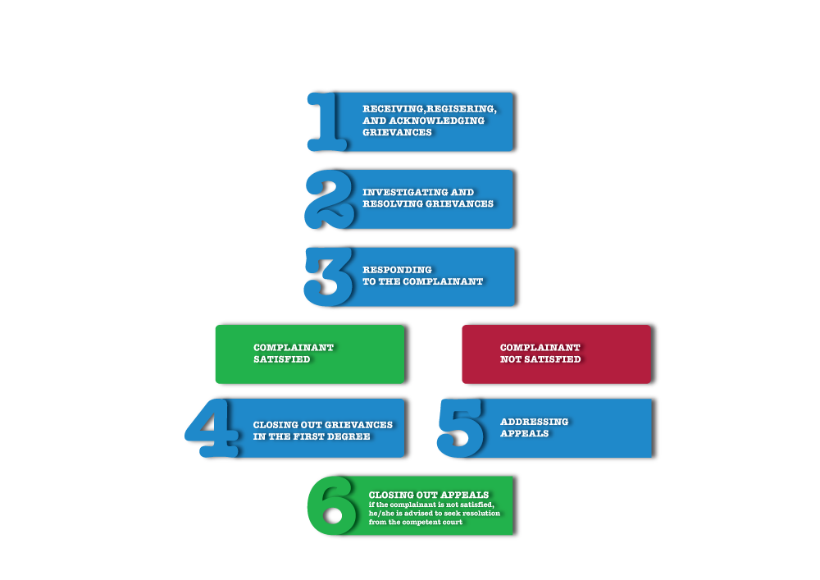
Figure 3 Steps for processing grievances

Phone Grievances

When grievances are received by phone, the grievance managers record details of the call in the grievance log, particularly the date when the call was made, the nature of the conversation and any other facts of significance. The grievance manager always attempts to agree with the complainant on how a written response can be provided to him/her (by email or post), to serve as a record of the process and outcome. If this is not possible, the record of the phone exchange made by the grievance manager in the grievance log, serves this purpose.

Local and Contractor Grievance Desk Details

The table below is regularly updated in this document by the Central Grievance Manager, as relevant information becomes available.

Sub Project / Territory | Locations of GM announcements | Contact details for Local Grievance Manager | Contact details for Contractor Grievance Manager

7 Submitting a Grievance

Any person who has a question or complaint in relation to the Serbia Railway Sector Modernization Project, should fill out the grievance form provided as ANNEX 1, or use it as guidance for preparing his/her submission. The grievance or question can be submitted by post or e-mail using the following contact details:

PIU of the Ministry of Construction, Transport, and Infrastructure
Central Grievance Desk of the Serbia Railway Sector Modernization Project
Attn. Central Grievance Manager: Ivan Radovanović, Social and Citizen Engagement Expert
Address: Uzun Mirkova 3, 11000 Belgrade, Serbia
e-mail: zalbe.srsm@mgsi.gov.rs
phone number: +381 63 8412 618 (During workdays from 10h to 13h)

Annex 1 - Grievance Form

MINISTRY OF CONSTRUCTION, TRANSPORT, AND INFRASTRUCTURE
Serbia Railway Sector Modernization Project
If you have questions or complaints in relation to the Serbia Railway Sector Modernization Project, please fill out this form or use it as guidance for preparing your submission. The grievance or question can be submitted by post or email, using the following contact details:

PIU of the Ministry of Construction, Transport, and Infrastructure
Central Grievance Desk of the Serbia Railway Sector Modernization Project
Attn. Central Grievance Manager: Ivan Radovanović, Social and Citizen Engagement Expert
Address: Uzun Mirkova 3, 11000 Belgrade, Serbia
e-mail: zalbe.srsm@mgsi.gov.rs
phone number: +381 63 8412 618 (During workdays from 10h to 13h)
Please note that we can only deal with questions or comments related directly to this Project, and not to the general work of the Ministry of Construction, Transport, and Infrastructure.

Reference No (to be filled in by responsible grievance manager):
Section 1 Contact Information (optional):
Note: you can remain anonymous if you prefer. In case of anonymous grievances, the response will be disclosed at the Projects website
❏ I wish to raise my grievance anonymously
Note: Your name and contact information will not be published or publicly available. The data will be used exclusively for possible further communication with you regarding the submitted question or complaint. Information on gender serves exclusively for statistical purposes, processing and analytical display; by declaring it, you are giving your consent for statistical data processing.

First name:
Last name:
Gender of complainant (optional): ❏ Male ❏ Female
Contact information:
Address:
E-mail:
Telephone:

Please mark how you wish to be contacted (mail, telephone, e-mail).
❏ By Post ❏ By Telephone ❏ By e-mail
❏ I will follow up on the response posted on the website as I want to remain anonymous

Preferred Language for communication ❏ Serbian ❏ Other _______________ (indicate)
Section 2 Grievance or Question (mandatory):
In case your question or grievance is connected to a specific event or the incident, please briefly describe: What happened? Where did it happen? Who did it happen to? What is the result of the problem? Date of incident/ grievance. Did it happen more than once? Is it still happening?

How do you see the potential solution for the problem?

Environmental and Social Standard no. 10 on Stakeholder Engagement and Information Disclosure, as part of the WB Environmental and Social Framework (2016), see: https://www.worldbank.org/en/projects-operations/environmental-and-social-framework/brief/environmental-and-social-standards
From 02.12.2022.; No. 340-01-00371/2022-04

