REQUEST FOR PARTICIPATION IN EARLY MARKET ENGAGEMENT

Procurement
of
Construction works on a connection line between Subotica – Bogojevo – State Border rail line and Novi Sad – Odžaci – Bogojevo rail line with reconstruction of Bogojevo railway station

Employer: Ministry of Construction, Transport and Infrastructure
Project: Serbia Railway Sector Modernization (SRSM) Project
Contract: Construction works on a connection line between Subotica – Bogojevo – State Border rail line and Novi Sad – Odžaci – Bogojevo rail line with reconstruction of Bogojevo railway station
Country: Republic of Serbia
Loan No.: 9221YF/CRS 1015 02D

Introduction
The Serbia Railway Sector Modernization (SRSM) Project is a long-term strategic initiative of the Government of the Republic of Serbia aimed at enhancing the operational, institutional, and technical performance of the national railway sector. It is implemented through a Multi-Phase Programmatic Approach (MPA) and financed by loans from the International Bank for Reconstruction and Development (IBRD) and the Agence Française de Développement (AFD), a structure suited to large-scale and complex reforms requiring sustained engagement over time. The Project is designed as a ten-year framework consisting of three interrelated phases with a total indicative value of approximately EUR 400 million, where each phase is legally independent but collectively contributes to a unified reform agenda focused on continuity, scaling of investments, and institutional strengthening.
The overarching objective of the SRSM Project is to support the modernization of Serbia’s railway sector through targeted infrastructure investments, digital transformation, improved asset management, enhanced maintenance capabilities, increased operational efficiency, and strengthened governance structures. To date, two phases have been contracted and are under implementation. Phase 1, effective since October 2021 with a total value of EUR 102 million equally financed by IBRD and AFD, is scheduled to run until December 2026 and has primarily focused on infrastructure reconstruction, preparation of technical documentation, institutional strengthening, and the introduction of digital and analytical solutions. Phase 2, effective since April 2025 with a total value of EUR 120 million and an implementation period extending to June 2029, builds upon the achievements of Phase 1 and continues the reform trajectory.
The Project is structured around three key components: infrastructure investments and asset management, which aim to improve the quality, safety, and management of railway assets; institutional strengthening and project management, which supports the development of policies and institutional capacity to sustain reforms; and railway modernization enablers, which focus on supporting vulnerable populations while promoting sustainable sector growth and job creation.

Within this framework, the Ministry of Construction, Transport and Infrastructure (MoCTI) intends to procure works for the construction of a new railway connection line between main railway line No. 110 and regional railway line No. 207, together with the reconstruction of Bogojevo railway station.
This investment is strategically important for improving network connectivity, operational flexibility, and freight and passenger flows in the north-western part of the Republic of Serbia, including cross-border connectivity toward Croatia.
- Purpose and Scope of the Early Market Engagement
This Early Market Engagement (EME) is conducted in accordance with the World Bank Procurement Regulations for IPF Borrowers and aims to engage proactively with the construction market prior to launching the formal procurement process.
The objectives of the EME are twofold:
- Market information and preparedness
The EME serves to inform potential contractors and industry stakeholders at an early stage about the project and planned procurement process, including their main features such as scope, anticipated contract structure, and implementation requirements. This allows interested firms to assess their interest, plan internal resources, explore potential partnerships, and prepare strategically for future participation.
The EME serves also to provide the Employer with understanding of the size, composition, key dynamics and capabilities of the target market.
- Market feedback and validation
The EME enables MoCTI to obtain structured feedback from the market on key elements of the proposed procurement approach, including:
  - Qualification and experience requirements;
  - Evaluation methodology;
The EME is not a prequalification, bidding, or selection process, and participation in the EME does not provide any advantage or disadvantage in any subsequent procurement procedure.
The focus of this EME is to:
- Check the availability and capacity of the market to respond to the project needs;
- Receive the feedback on the appropriateness and proportionality of qualification criteria;
- Test whether the procurement strategy and corresponding procurement approach have been defined in a competitive, realistic, and implementable manner under prevailing market conditions;
- Identify potential risks, constraints, or opportunities that may affect the success of the procurement process and/or project delivery;
- Support the design of a fair, transparent, and competitive tendering process that delivers value for money.
The outcomes of the EME will be used solely to refine the procurement strategy and procurement documents prior to launching the formal tender, in line with World Bank requirements on transparency, equal treatment, and integrity.

Specific Project Details
Bogojevo railway station is a strategically important junction within the Serbian railway network, providing connections between Novi Sad on one axis and Sombor and Subotica on the other. Under the current track layout and operational concept, trains arriving from one direction are required to enter Bogojevo station and perform shunting operations in order to reverse direction before continuing toward their final destination (Figure 1).
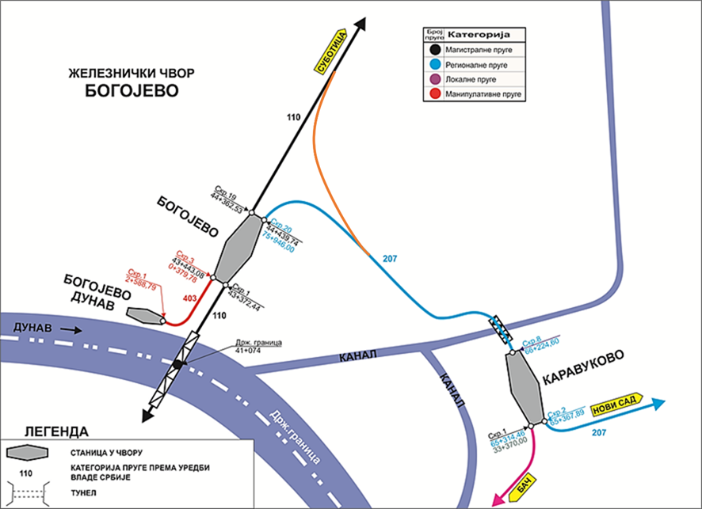
Figure 1 - Bogojevo rail junction

This operational constraint results in significant dwell times, increased complexity of train operations, and reduced network efficiency. In particular, the existing junction configuration does not allow for direct train movements between Pančevo, Novi Sad, and Subotica. As a consequence, trains must enter Bogojevo station for direction changes, which leads to longer travel times and requires additional engagement of operational staff from both Serbian Railways Infrastructure (IZS) and freight railway undertakings. These inefficiencies directly translate into higher operating and transportation costs, particularly for freight traffic.
To address these constraints and streamline railway operations, the MoCTI plans to construct a new 1.41km railway connection line (bypass) that will enable direct train movements without entering Bogojevo station. The proposed solution consists of forming a triangular junction layout by connecting the existing railway lines Subotica – Bogojevo – State Border (Erdut) and Novi Sad – Odžaci – Bogojevo.
The new connection line is estimated to be approximately 1.4 km in length and will allow through-running trains between Novi Sad and Subotica to bypass the station entirely, thereby significantly reducing travel times, simplifying operations, and improving overall rail line performance.
Within Phase 1 of the SRSM Project, a Feasibility Study and Preliminary Design for the Bogojevo junction improvement have already been prepared. Based on these studies, the project comprises the following scope of works:
- Construction of a new 1.41 km single-track railway line (the so-called “triangle line”) to bypass Bogojevo Station and connect the existing railway lines;
- Reconstruction of approximately 1.65 km of the existing Subotica – Bogojevo railway line;
- Reconstruction of approximately 1.45 km of the existing Novi Sad – Bogojevo railway line;
- Reconstruction of seven station tracks within Bogojevo station;
- Reconstruction of two existing level crossings and construction of one new level crossing, including adaptation of agricultural access roads in the crossing areas;
- Adaptation of two rooms within the existing station building;
- Installation of signaling and safety systems;
- Installation of telecommunication systems;
- Construction and reconstruction of six culverts, together with protection and reconstruction of the existing canal and drainage network.
For the execution of this project, MoCTI plans to launch a works contract procurement using Design and Build approach which incorporates contract conditions from Yellow Fidic Book, Second edition 2017. The contractor will be e responsible both for the construction works, and for the preparation of the Building Permit Design documentation.
The Contractor will be required to prepare all necessary design documentation in full compliance with the Law on Planning and Construction of the Republic of Serbia (Official Gazette of RS No. 72/2009, 81/2009, 64/2010, 24/2011, 121/2012, 42/2013, 50/2013, 98/2013, 132/2014, 145/2014, 83/2018, 31/2019, 37/2019, 9/2020, 52/2021, and 62/2023), as well as the Rulebook on the Content, Manner and Procedure of Preparation and Control of Technical Documentation According to the Class and Purpose of the Facility (Official Gazette of RS No. 96/2023).
The Building Permit Design will serve as the basis for obtaining the construction permit from the competent authority within MoCTI.
In line with this procurement approach, appropriate qualification and technical criteria have been developed and are included in the EME questionnaire, with the objective of validating their proportionality, clarity, and alignment with market capabilities prior to launching the formal tender procedure.

EME questionnaire and event
We kindly inform interested companies that, in addition to completing the attached questionnaire, an online EME event will be organised to provide the market with an opportunity to learn more about the Project and foreseen procurement process. During the virtual session, the key aspects of the project, outline the proposed procurement approach, and invite participants to share their views, raise questions, and provide feedback on the proposed design and qualification criteria.
In this context, potential companies are invited to provide input on the proposed qualification criteria and related requirements to help us validate that they are proportionate, realistic, and supportive of a competitive and high-quality bidding process. The MoCTI guarantees that all information provided at this stage will be handled with high confidentiality in accordance with WB Procurement Regulations and will not be treated as binding for bidders in any future procurement process. Therefore, the MoCTI hereby invite interested recipients to respond on the attached Questionnaire.
The participation in this inquiry is voluntary and will not have any consequences for later participation. Moreover, please note that no feedback to your answers will be given. If your company is generally not interested in participating in the EME event, we would appreciate a short notice.
In case of general interest, we kindly request to fill-out attached Questionnaire.
All received responses will be reviewed carefully, and the feedback will be analyzed collectively to determine whether any adjustments are needed to the tender documentation before finalization.
As part of EME, interested companies are required to register for the event and submit filled out questionnaire (please see below) through email to:
larisa.puzovic@mgsi.gov.rs; miroslav.prokic@mgsi.gov.rs; tanja.tosic@mgsi.gov.rs;

latest by April 27, 2026. Please note that responses to the questions will be shared only internally with the Project Implementation Unit and will not be made public or available to your competitor companies.
On April 29, 2026 at 13:00 hours Belgrade time, Project Implementation Unit will arrange virtual EME event, during which more deep discussions about the project will take place. During the session, the participants will have the opportunity to provide its feedback and share their experience and recommendations regarding the project design, evaluation criteria, and other relevant aspects. The link for the EME meeting is:
https://saigeprojectrs.webex.com/saigeprojectrs/j.php?MTID=mcd1f254c13664ad70e13a6e29cd90a91

EME Questionnaire
Please note that responses to the questions will be shared only internally with the Project Implementation Unit and will not be made public or available to your competitor companies.

Question | Answer
General information
What is your company’s official name?
What is your company’s official address?
In which countries does your company operate and/or has branches?
What is the profile of your company and how many years has your company in this profile business?
Does your company operate internationally or regionally?
Does your company have subsidiaries, representative offices, or affiliated companies in other countries? If yes, please specify.
Financial capability and turnover requirements
Please briefly describe your company’s financial capacity to support the execution of a project of this nature.

In your response, please indicate the types of financial resources available, such as:

as liquid assets, unencumbered real assets, existing lines of credit, or other financial means, excluding any contractual advance payments from ongoing or future contracts.

What was the overall annual turnover of your company per year for the last 3 years? | 2023: XXXXX (USD / EUR / any other currency)  2024: XXXXX (USD / EUR / any other currency)  2025: XXXXX (USD / EUR / any other currency)
Please provide a proposal for the percentage of advance payments required for the contract with explanation.
General and specific design and construction experience
Do you have experience working under FIDIC contract conditions (please specify which book and contract type)?

Please list all prepared Designs (preliminary and Design for Building permit) for construction and reconstruction of railway infrastructure during the last 10 years. | List of similar contracts:
If your company does not prepare designs or is not engaged in design activities, please indicate your proposal regarding the minimum number, value, and complexity of projects that should be required as a condition for participation in the tender.

Please indicate whether your company has an in-house design department, has established cooperation agreements with design firms, or intends to participate as part of a Joint Venture with a design company.

Please list all contracts of a similar nature related to the construction or reconstruction of public railway infrastructure. For each referenced contract, please provide, where applicable, with a brief description of the scope of work, the total contract value, level of completeness, and the country of implementation.  In particular, please specify experience, if any, in one or more of the following areas:  - Reconstruction or upgrading of existing railway lines and station tracks;  - Works within active railway stations or operational railway environments;  - Installation or upgrading of railway signalling and safety systems;  - Installation or upgrading of railway telecommunication systems.  In case your company was in Joint Venture (JV), or subcontracted by another company, in addition to the contracts price, please also indicate in % what was the share of your company from the contract price. Examples are:  Contractor as Single Entity with contract price of XXXX [currency]; the contract included implementation of following main components in [country]: …..  Contractor in JV with [please list other JV members] as [Lead or Member] with contract price of XXXX [currency]; with XX% share for our company; our part included implementation of following main components in [country]: …..  Sub-contractor of [please indicate the name of Single Entity or all JV members (as applicable)] for a contract with contract price of XXXX [currency]; with XX% share for our company; our part included implementation of following main components in [country]: ….. | List of similar contracts:
According to your experience with similar projects for construction and reconstruction railway infrastructure, what would be a realistic implementation timeline (both for design and execution), and what are the main constraints affecting implementation?
National licenses and certifications
Please provide your feedback regarding the availability and attainability of the national licensing and certification requirements applicable in the Republic of Serbia for the proposed contract. Due to the need to facilitate timely project execution, the preparation of the Building Permit Design will need to commence as soon as possible after the contract becomes effective.

Considering the scope of works, the licenses required for the preparation of the Building Permit Design include:
- P141G2 – Design of public railway infrastructure projects with connections.
- P141S1 – Design for traffic and traffic signalization for public railway infrastructure with connections.
- P141E4 – Design of electric drive management systems, including automation, measurement, and regulation, for public railway infrastructure with connections.

The preparation of technical documentation requires the engagement of engineers holding personal professional licenses, in accordance with the Rulebook on Taking Professional Exams in the Field of Spatial and Urban Planning, Preparation of Technical Documentation, Construction and Energy Efficiency, as well as the Rulebook on Licenses for Responsible Persons and Registration in the Register of Licensed Engineers, Architects, and Spatial Planners (Official Gazette of the Republic of Serbia No. 51/2019 and 2/2021 – other rulebook).

We kindly ask you to provide your views on whether this requirement would affect your motivation to submit a bid and to share any comments, suggestions, or recommendations regarding this requirement.

In addition, for the execution of works, the following licenses and certifications applicable in the Republic of Serbia are required:
- I141G2 – Execution of works on public railway infrastructure with connections.
- I141E3 – Execution of telecommunication networks and systems for public railway infrastructure with connections.
- Certificate issued by the Directorate of Railways of Serbia, confirming compliance with the conditions for maintenance of upper and lower railway track structures.

In order to ensure greater competition, bidders will be allowed to be awarded the contract even if they do not possess these licenses and certification at the time of contract signing. However, the proof of existence of licenses will be required to commence the works. (i.e., during the design phase).

Would these licensing requirements affect your decision to participate in the tender? If so, please explain how.

One of the requirements will be that a minimum of 30% of the labor force is local. Do you see this requirement as a potential constraint for your participation, or would it not represent a problem for your company?

Rated criteria (technical evaluation).

As part of the upcoming tender, the following technical evaluation criteria are planned to be applied when assessing the quality of technical proposals:
- Design Methodology (weight: 40%) – evaluation of the proposed approach to preparing the Building Permit Design and Construction Design, including understanding of the regulatory framework in Serbia, design sequencing, coordination between disciplines, and management of design-related risks.
- Implementation Methodology Documents (weight: 40%) – evaluation of the overall implementation approach, including the Design Programme, Site Organization Plan, Method Statement, Mobilization, and Construction Schedules, with particular attention to integration of design and construction, phasing, realism of timelines, and efficiency measures.
- Equipment and Machinery Capacity (weight: 20%) – evaluation of access to and use of advanced railway construction equipment that ensures productivity, quality, and reliability of execution (e.g. tamping machine, flash-but welding machine etc.).
- Would the above evaluation criteria be a concern to your company? If so, indicate why.
- Do you consider these criteria adequate for ensuring a fair and objective assessment of technical proposals under the contract?
- Would you suggest any additional or alternative technical evaluation criteria that, in your opinion, could better reflect the specific nature and success factors of this project?
Additional feedback
Please list any other thoughts, concerns, barriers or risks you see; or that may influence or prevent you from participating in the bidding.
Do you intend to participate in procurement covered by this questionnaire?

If yes, do you plan to participate as sole bidder, in JV or as sub-contractor (please indicate the appropriate form of participation)

If yes, how would you organize to provide the required design services?

