Republic of Serbia
Ministry of Construction, Transport and Infrastructure
Nemanjina 22-26, 11000 Belgrade
Phase 2

Stakeholder Engagement Plan (SEP)

for the
PHASE 2 OF THE MULTI-PHASE PROGRAMMATIC APPROACH

Serbia Railway Sector Modernization Project

Draft Document

September 2023

Table of Contents

1 INTRODUCTION 7
1.1 Project Description 7
1.2 Purpose and justification for the Project level SEP for Phase 2 8
1.3 Scope and structure of the P2PSEP 9
1.4 Summary of potential environmental and social impacts 9
1.5 Project Locations 9
1.6 National Legislation Requirements 10
1.7 World Bank’s Environmental and Social Standard on Stakeholder Engagement (EES10) 11
2 SUMMARY OF PREVIOUS STAKEHOLDER ENGAGEMENT ACTIVITIES 12
3 STAKEHOLDER IDENTIFICATION AND ANALYSIS 13
3.1 Parties Potentially Affected by Phase 2 of the Project 13
3.2 Other Interested Parties 14
3.3 Disadvantaged or Vulnerable Individuals or Groups 14
3.4 Summary of stakeholder engagement needs and Analysis of their Interest and Influence 15
3.5 Stakeholder expansion 20
4 STAKEHODLER ENGAGEMENT PROGRAM 21
4.1 Purpose and timing of stakeholder engagement program 21
4.2 Proposed Strategy for Disclosure 21
4.3 Proposed Strategy for Consultation 22
4.4 Proposed strategy to incorporate the view of vulnerable groups 28
4.5 Timeline. 28
4.6 Review of comments 28
4.7 Future Phases of Project 28
4.8 Development of Sub-Project Level SEPs (SPSEP) 29
5 RESOURCES AND RESPONSIBILITIES FOR IMPLEMENTING STAKEHOLDER ENGAGEMENT ACTIVITIES 31
5.1 Resources 31
5.2 Management Functions and Responsibilities 31
6 GRIEVANCE MECHANISM 33
6.1 Purpose of the Grievance Mechanism 33
6.2 Grievance Mechanism Principles 33
6.3 Organization of the GM 34
6.3.1 Local Grievance Desk 35
6.3.2 Contractor Grievance Desk 36
6.3.3 Central Grievance Desk 36
6.3.4 Second-Degree Appeals Committee of the Ministry 37
6.4 Processing of Grievances 37
6.4.1 Processing Steps 37
6.5 Phone Grievances 39
6.6 Local and Contractor Grievance Desk Details 40
6.7 Submitting a Grievance 40
6.8 World Bank Grievance Redress Service 41
7 MONITORING AND REPORTING 42
7.1 Reporting back to stakeholder groups 43
8 REPORT ON PUBLIC DISCLOSURE AND PUBLIC CONSULTATION 43

List of Figures
No table of figures entries found.

List of Tables
Table 1: Influence and interest matrix 14
Table 2: Level of stakeholder engagement based on their level of interest and level of influence 15
Table 3: Expansion and update questionnaire 19
Table 4: Proposed Strategy of Consultation 23
Table 5: Tentative budget Categories for effective implementation of engagement activities 33
Table 6: Management functions and responsibilities 33
Table 7: CFD contact details. 40
Table 8: Monitoring indicators 42

ABBREVIATIONS
CGD | Central Grievance Desk
E&S | Environmental and Social
ESCP | Environmental and Social Commitment Plan
ESF | Environmental and Social Framework
ESMF | Environmental and Social Management Framework
ESMP | Environmental and Social Management Plan
ESS | Environmental and Social Standards
GM | Grievance Mechanism
GoS | Government of Serbia
GRS | Grievance Redress Service
IZS | Infrastructure Železnice Srbije
LGAD | Local Grievance Admission Desk
MCTI | Ministry of Construction, Transport and Infrastructure
MoF | Ministry of Finance
MPA | Multiphase Programmatic Approach
NGO | Non-Governmental organization
OG | Official Gazette
OHS | Occupational Health and Safety
OIP | Other Interested Parties
PAP | Project Affected Person
PIT | Project Implementation Team
PIU | Project Implementation Unit
PSEP | Project Level Stakeholder Engagement Plan
RD | Railway Directorate
RPF | Resettlement Policy Framework
RS | Republic of Serbia
SC | Srbija Cargo
SEA/SH | Sexual Exploitation and Abuse /Sexual Harassment
SOE | State Owned Enterprise
SPSEP | Sub-Project Level Stakeholder Engagement Plan
SV | Srbija Voz
WB | World Bank

GLOSSARY
Consultation: The process of sharing information and getting feedback and/or advice from stakeholders and taking these views into account when making project decisions and/or setting targets and defining strategies.
Environmental and Social Standards (ESSs): The 10 Environmental and Social Standards (ESSs) setting out the requirements that apply to all new World Bank investment project financing enabling the World Bank and the Borrower to manage environmental and social risks of projects.
Project: Refers to the Rail Modernization Project supported by the World Bank and implemented by the Ministry of Construction, Transport and Infrastructure through a Project Implementation Unit (PIU) and technically supported by Project Implementation Teams (PITs) housed under Railway Directorate (RD), Infrastruktura Železnice Srbije (IZS), Srbija Cargo (SC) and Srbija Voz (SV) respectively.
Project Affected parties: include those affected or likely to be affected by the project because of actual impacts or potential risks to their physical environment, health, security, cultural practices, well-being, or livelihoods. These stakeholders may include individuals or groups, including local communities.
Other interested parties: refers to individuals, groups, or organizations with an interest in the project, which may be because of the project location, its characteristics, its impacts, or matters related to public interest. For example, these parties may include regulators, government officials, the private sector, the scientific community, academics, unions, women`s organizations, other civil society organizations, and cultural groups.
Stakeholders: Collective reference to individuals or groups who: (a) are affected or likely to be affected by the project (project-affected parties); and (b) may have an interest in the project (other interested parties).
Stakeholder engagement: is the continuing and iterative process by which the Borrower identifies, communicates, and facilitates a two-way dialogue with the people affected by its decisions and activities, as well as others with an interest in the implementation and outcomes of its decisions and the project. It takes into account the different access and communication needs of various groups and individuals, especially those more disadvantaged or vulnerable, including consideration of both communication and physical accessibility challenges. Engagement begins as early as possible in project preparation because early identification of and consultation with affected and interested parties allows stakeholders views and concerns to be considered in the project design, implementation, and operation.
Project level Stakeholder Engagement Plan (PSEP): This Plan document prepared to guide development of sub-project specific SEPs, and ensure effective stakeholder engagement while transitioning towards them.
Sub-project level Stakeholder Engagement Plan (SPSEP): Sub-Project specific document assisting in effective engagement with stakeholders throughout the life of the project and specifying ground rules who, when, why and how should be receiving information, providing feedback and be meaningfully consulted. These will be prepared as soon as the specific locations, technical and technological details, stakeholder groups, and schedule of activities are known.

INTRODUCTION

Project Description

The World Bank (WB) aims to support the Government of Serbia in continuation of institutional, physical and operational modernization of the railway sector in an integrated manner through providing financial support to Serbia Railway Sector Modernization Project (hereinafter: the Program) as part of the Multiphase Programmatic Approach to be implemented in three phases over the ten-year period. Sectoral changes are planned to: (1) strengthen the management of the sector, giving companies clear and achievable contractual arrangements; (2) infrastructure improvement; (3) encouraging railway companies to increase their corporate efficiency and achieve their commercial goals; (4) improving the reliability and safety of railway services through the use of modern technology, modern safety systems, energy efficiency measures and consideration of resilience; and (5) increasing rail modal participation by working on last-kilometer connectivity, urban integration, multimodal logistics centers and the concept of integrated territorial development.

Phase 2 of the Program (hereinafter: the Project), the subject of this SEP, would prioritize investments in the overhaul maintenance workshops and refurbishment of existing rail maintenance machinery with procurement of new rail maintenance machinery thus strengthening the railway sector on the field of maintenance. This is expected to be the largest phase by investment amount. The Project will utilize the knowledge originated in Phase 1 on rail asset management, ownership structure, further corporatization, modal shift interventions and commercialization of the sector, with special emphasis on railway infrastructure maintenance. In addition, it would scale up and finish implementation of the SMS to improve safety performance and establish a safety culture together with continuation of introduction of digital solution in operational activities. These efforts will be coupled with scaled-up infrastructure investments coherent with the main objective of the Project. The Project may also begin the utilization of intelligent transportation systems (ITS) and pilot integration of rail and bus services. The integration of intercity and urban rail services (freight and passenger) with other modes will be continuing to improve operational safety. The next three pilots for Integrated Territorial Development (ITD) will be conduct, as a continuing activity from Phase 1. These measures would not only benefit wider local communities but also provide climate co-benefits. Also, the Project will recognize private investments opportunities throughout the analysis of construction of new logistics centers and intermodal terminals with and cargo-oriented developments (COD) that will provide clear opportunities for the private sector to participate.

Phase 2 is structured along the same three components as in the Program first phase. The overall focus on Phase 2 is on railways infrastructure routine maintenance, yet includes activities that: (i) build up on Phase 1 activities; and (ii) prepare Phase 3 activities. In particular, Phase 1 establishes the Railway Infrastructure Asset Management System (RIAMS) that will be IZS’s keystone to plan and optimize asset management, including maintenance. Phase 2 content is defined based on the need to initiate multiphase approach (MPA) Phase 2 and on the lessons learned from Phase 1.

The Project will be implemented through three components and accompanied sub-components:

Component 1: Infrastructure Investments and Asset Management: Sub-Component 1.1: Heavy duty machinery for railways infrastructure maintenance, Sub-Component 1.2: Modernization of railways maintenance facilities, Sub-Component 1.3: Outsourcing railways routine maintenance, Sub-Component 1.4: Railways asset management and planning, Sub-Component 1.5: Preparation of technical documentation for railway lines

Component 2: Institutional Strengthening and Project Management: Sub-Component 2.1: Sectoral governance and commercial approach, Sub-Component 2.2: Human Capital Development, Sub-Component 2.3: Project Management and Citizen Engagement

Component 3: Railway Modernization Enablers: Sub-Component 3.1: Growing Cargo Traffic, Sub-Component 3.2: Growing Passenger Traffic.

Purpose and justification for the Project level SEP for Phase 2

Operations and activities for which the World Bank`s Investment Project Financing (IPF) is sought after October 1, 2018, fall under the application of the Environmental and Social Framework (ESF). The ESF comprise, inter alia, the 10 Environmental and Social Standards which set out mandatory requirements for the Borrower and the Project. Under the ESS10, a Stakeholder Engagement Plan (SEP) should be developed prior to Project appraisal that sets out the principles and procedures for stakeholder engagement in a manner that is consistent with ESS10. A Project level SEP for Phase 1 of the Project has already been prepared and is being implemented, while this document addresses Phase 2 of the Project.

Project level Stakeholder Engagement Plan (PSEP) for Phase 2 (P2PSEP)

In response to the commitment of the GoS to comply with the ESF and WB Requirements, the Ministry of Construction, Transport and Infrastructure (MCTI) has developed this P2PSEP laying out the approach to meeting the objectives of World Bank ESS 10: Stakeholder engagement.

Specifics such as project locations, technical and technological details, and other key factors of the individual subcomponents are not known and will be decided at a future date, which is why a Phase 2 project level stakeholder engagement Plan is deemed appropriate to guide the development of sub-component or sub-project specific SEPs, as soon as the specific locations, stakeholder groups, and schedule of activities are known. This is part of an iterative process in communicating with stakeholders who may be affected by or might be interested in Phase 2 of the Project throughout its life cycle. To allow uptake of Stakeholders concerns and problems during the project planning stage a fully functional Grievance Mechanism has already been developed for Phase 1 and is being implemented. This same Grievance Mechanism will be used for Phase 2 of the Project and is presented in detail in chapter 6.

In Phase 2 of the Project, the following principles for stakeholder engagement throughout the project cycle will be implemented:

- Openness and life-cycle approach: public consultations for the project(s) will be arranged during the whole life cycle, carried out in an open manner, free of external manipulation, interference, coercion or intimidation;
- Informed participation and feedback: information will be provided to and widely distributed among all stakeholders in an appropriate format; opportunities are provided for communicating stakeholders’ feedback, for analyzing and addressing comments and concerns;
- Inclusiveness and sensitivity: stakeholder identification is undertaken to support better communications and build effective relationships. The participation process for the projects is inclusive. All stakeholders at all times encouraged to be involved in the consultation process. Equal access to information is provided to all stakeholders. Sensitivity to stakeholders’ needs is the key principle underlying the selection of engagement methods. Special attention is given to vulnerable groups, in particular women, youth, elderly and the cultural sensitivities of diverse ethnic groups.

Scope and structure of the P2PSEP

The stakeholder engagement will be integrated into project’s environmental and social performance and project design and implementation. The scope of the P2PSEP follows the World Bank’s ESS10 requirements. The adequacy of the engagement methods shall be part of the Monitoring & Evaluation (M&E) segment of the Project.

Summary of potential environmental and social impacts

The potential project level environmental and social impacts, as identified in the ESMF likely to be the adverse and beneficial impacts of the project and the focal topics for stakeholder engagement activities, include, but are not limited to:

- Permanent and temporary acquisition of land,
- Physical or economic displacement, loss of assets, loss of livelihood and related compensation procedures,
- Potentially significant impact to sensitive and valuable natural areas
- Potentially impact to the forest, natural habitats and protected areas
- Potentially impact to cultural heritage including archeological sites
- Temporary restriction in access to land,
- Labor influx,
- Temporary diversions and closure of rail routes and access roads,
- Community health and safety from construction works,
- Potential impacts on air quality due to movement of vehicles and equipment, earthworks, open piles of topsoil and spoil, and the operation of combustion engines and/or,
- Noise, dust, waste generation and traffic disturbance from construction vehicles and machinery,
- Generation of local income through the recruitment of workers from local communities to the project,
- The Project`s added value and community benefits and support.
The Sub-project specific SEPs will elaborate on the details of impacts of relevance to affected and interested parties and will tailor messages accordingly.

Project Locations

There are only three locations where construction works that might have any effect on environment and stakeholders are planned locations of workshop reconstruction: Sailovo, Lapovo and Batajnica. Potentially ESS6 standard can be relevant for construction works, and it will be concluded during preparation of relevant designs which will be included conditions from Institute for nature protection. ESS8 is not relevant for this workshop reconstruction.

National Legislation Requirements

The commitments and requirements of the Republic of Serbia to citizen engagement are not residing under a single self-standing law or regulation. However, the recognition of importance of citizen engagement is infused in the legal system and clearly recognized by mandatory procedures provided under individual laws. Serbia having acquired the EU candidate country for membership status, is taking a huge effort to reach environmental standards in line with the EU acquis which extends to issues of stakeholder and citizen engagement as well.
From the highest legal act down to an ample normative framework comprising the Serbian legal system, a strong commitment and openness to stakeholder engagement is evident. Key laws governing the stakeholder and citizen engagement activities include, but are not limited to:

The Constitution of the Republic of Serbia (2006)
proclaims the rule of law and social justice, principles of civil democracy, human and minority rights and freedoms, and commitment to European principles and values. The Article 74 proclaims the right to healthy environment and grants the right to timely and comprehensive information on the state of the environment.

The Law on free access to information of public interest (2004)
states that governmental agencies, social associations and officials are required to provide each person with the possibility of receiving and becoming acquainted with documents of public interest, except in cases anticipated by law. By virtue of this Law access to information shall be granted to all stakeholders, including every natural person or legal entity upon written request unless otherwise regulated by the Law. Within 15 days of receipt of a request at the latest, the authority shall inform the applicant whether the requested information is held, and grant him/her access to the document containing the requested information or issue or send to the applicant a copy of the document, as the case may be.

Law on Public Information and Media (2014)
stipulates that public information is free and is not subject to censorship, that the public has the right and the interest to be informed on issues of public interest, that monopoly in the media is not allowed, that information on the media is public.

The Law on Environmental Impact Assessment (2004 as amended in 2009)
provides categorization of industries and projects and identifies types of environmental assessment required against respective categories of industries or projects and provides procedures for disclosure, presentation and consultation requirements, and sets these as mandatory with a disclosure minimum of a minimum of 20 days.
The Republic of Serbia ratified the Aarhus Convention on Access to information, public participation in decision-making and access to justice in environmental matters and it links environmental and human rights and is based on the belief that it is a basic right of present and future generations to live in an environment adequate to health and wellbeing. The convention is focused on achieving this through the implementation of three pillars: rights of access to information, access to decision-making, and access to justice.

Other stakeholder engagement, disclosure and transparency requirements within certain topics and sectors are embedded in the applicable laws regulating each of the treated subject. They are broadly compliant to the requirements of ESS10 but have certain shortcomings when it comes to active outreach and continuous engagement strategies.

World Bank’s Environmental and Social Standard on Stakeholder Engagement (EES10)

The World Bank’s ESS 10, “Stakeholder Engagement and Information Disclosure”, recognizes “the importance of open and transparent engagement between the Borrower and project stakeholders as an essential element of good international practice”. Specifically, the ESS10 requires the following:

- “Borrowers will engage with stakeholders throughout the project life cycle, commencing such engagement as early as possible in the project development process and in a timeframe that enables meaningful consultations with stakeholders on project design. The nature, scope and frequency of stakeholder engagement will be proportionate to the nature and scale of the project and its potential risks and impacts.
- Borrowers will engage in meaningful consultations with all stakeholders. Borrowers will provide stakeholders with timely, relevant, understandable and accessible information, and consult with them in a culturally appropriate manner, which is free of manipulation, interference, coercion, discrimination and intimidation.
- The process of stakeholder engagement will involve the following, as set out in further detail in this ESS: (i) stakeholder identification and analysis; (ii) planning how the engagement with stakeholders will take place; (iii) disclosure of information; (iv) consultation with stakeholders; (v) addressing and responding to grievances; and (vi) reporting to stakeholders.
- The Borrower will maintain and disclose as part of the environmental and social assessment, a documented record of stakeholder engagement, including a description of the stakeholders consulted, a summary of the feedback received and a brief explanation of how the feedback was taken into account, or the reasons why it was not.” (World Bank, 2017: 98).

In certain instances, where the specifics for creating a detailed Stakeholder Engagement Plan are not available, a stakeholder engagement framework (SEF) may be adopted. The SEF will guide the development of a SEP, as soon as the specific locations, stakeholder groups, and schedule of activities are known. It has to be disclosed as early as possible, and before project appraisal, and the Borrower needs to seek the views of stakeholders on the SEF, including on the identification of stakeholders and the proposals for future engagement.

SUMMARY OF PREVIOUS STAKEHOLDER ENGAGEMENT ACTIVITIES

The specific nature of the Project required a broad engagement with various project stakeholders with main discussions between the World Bank and the Government, institutional and sector specific institutional Stakeholders.

The specific stakeholder engagement activities that have taken place during Project preparation include:

- Numerous discussions and communication exchange between the World Bank and government agencies at the national, regional and local level;
- Communication and meetings with other national and international donors working in the rail sector;
- Review of project preparation status with representatives from the Ministry of Construction, Transport and Infrastructure and including safeguard documentation;
- Multiple meetings and communication exchange with the Infrastructure Železnice Srbije discussing the Project design, investment priority needs;
- Multiple meetings and communication exchange with Srbija Cargo discussing the Project design;
- Multiple meetings and communication exchange with Rail Directorate discussing the Project design.

While the project plans to conduct an active engagement with non-state stakeholders during implementation as soon as the preparation of subprojects starts, a gender in transport survey was conducted during preparation and feedback received from female population has been used for the design of the project. The feedback received includes the development of passenger rail services which many poorer female populations in particular those in rural areas consider. This would significantly improve their mobility and socioeconomic conditions as rail services typically provide lower cost and safer means of transport. In addition, an active media campaign was conducted to inform the general public about the project. An active stakeholder engagement will be conducted following approaches provided in this P2PSEP once the project implementation starts and their feedback will be incorporated into the design of project activities.

STAKEHOLDER IDENTIFICATION AND ANALYSIS

ESS10, read in conjunction with ESS1, recognizes the following categories of stakeholders:

1) Project Affected Parties. These includes those likely to be affected by the project because of actual impacts or potential risks to their physical environment, health, security, cultural practices, wellbeing, or livelihoods. These stakeholders may include individuals or groups, including direct project beneficiaries and local communities. They are the individuals or households most likely to observe/feel changes from environmental and social impacts of the project.

2) Other Interested parties (OIPs) refers to: individuals, groups, or organizations with an interest in the project, which may be because of the project location, its characteristics, its impacts, or matters related to public interest. For example, these parties may include regulators, government officials, the private sector, the scientific community, academics, unions, women’s organizations, other civil society organizations, and cultural groups. The stakeholder identification has been expanding to a wider area than the project will affect, since the locations have not all been identified and important details of project activities are still under development.

3) Disadvantaged/Vulnerable Individual or Groups. Includes those who may be more likely to be adversely affected by the project impacts and/or more limited than others in their ability to take advantage of a project’s benefits. Such an individual/group is also more likely to be excluded from/unable to participate fully in the mainstream consultation process and as such may require specific measures and/ or assistance to do so. This will take into account considerations relating to age, including the elderly and minors, and including in circumstances where they may be separated from their family, the community or other individuals upon whom they depend.

Parties Potentially Affected by Phase 2 of the Project

Parties Potentially Affected by Phase 2 of the Project, who are therefore considered stakeholders, are likely to include the following:

- Passengers
- Freight companies
- Persons residing in areas where Sub-project specific works will be executed
- Persons affected by land acquisition and resettlement
- Businesses who may be affected by any land acquisition related activities or construction activities implemented as part of the subprojects
- Women benefitting from a new HR strategy for State Owned Enterprise (SOE) railway sector companies
- Vulnerable groups
- The Ministry of Construction, Transport and Infrastructure (MCTI)
- The Railways Directorate (RD)
- Serbian Railways Infrastructure (IZS)
- Serbia Voz (SV)
- Serbia Cargo (SC)
- Serbian Railways AD
- Private rail cargo operators.
- Rilawys station staff, conductors and train drivers
The sub-project specific SEPs to be prepared at later stages will expand the list of projects affected parties and include for each sub-project those likely adversely by the project activities. These may also include parties affected by beneficial impacts, but the focus of engagement shall lie on drivers of the adverse impacts.

Other Interested Parties

'Other Interested Parties’ constitute individuals, groups, entities that may not experience direct impacts from the project but who consider or perceive their interests as being affected by the project and/or who could affect the project and the process of its implementation in some way. Accordingly, there are a number of other stakeholders who have a stake, have expressed, or may express interest due to a variety of reasons. They include project implementing agencies, project partners, political institutions, service providers, host communities, civil society organizations, NGOs, religious institutions, political authorities, academic institutions, and project beneficiaries.

Disadvantaged or Vulnerable Individuals or Groups

Of particular importance is to understand whether adverse project impacts may disproportionately fall on disadvantaged or vulnerable individuals or groups, or they are likely to be excluded/unable to access Project benefits. Such groups may often not have a voice to express their concerns or understand the impacts of a project. This P2PSEP shall ensure that disadvantaged or vulnerable individuals or groups, relevant to the project, are identified, that their particular sensitivities, concerns and barriers to project information are assessed and that they fully understand project activities and benefits and participate in consultation processes. The vulnerability may stem from person’s origin, gender, age, health condition, economic deficiency and financial insecurity, disadvantaged status in the community (e.g. minorities or fringe groups), dependence on other individuals or natural resources, etc. Engagement with the vulnerable groups and individuals often requires the application of specific measures and assistance aimed at the facilitation of their participation in the project-related decision making so that their awareness of and input to the overall process are commensurate to those of the other stakeholders.

The specific details of groups and individuals vulnerable to impacts from the project are not yet known since the details of locations and technological issues of activities are still to be identified. The drivers of vulnerability will be in details assessed and identified during development of the sub-project specific P2SEPs. Based on the initial screening some of the identified groups may include:

- Retired elderly and people with disabilities and chronical disease;
- Single parent headed households, male and female;
- People with low literacy and ICT knowledge,
- Economically marginalized and disadvantaged groups,
- Persons living below the poverty line
- Women.

Vulnerable groups affected by the project will be further confirmed through the process of preparation of sub-project specific SEPs and consulted through dedicated means, as appropriate.
As the Program addresses passenger rail services, there would be scope for improved mobility for people in rural areas, people with disabilities, and/or the elderly to gain better access to railways services and jobs in the case they are interested and qualified to work within railway transport industry . It will be important to analyze the gender implications of the Program, as women’s experiences with transport systems differ from those of men, particularly as related to decision-making, facilities planning, safety, reliability, affordability, and accessibility.

Summary of stakeholder engagement needs and Analysis of their Interest and Influence

Identified stakeholder groups and their level of influence cross-referenced with the interest they may have in the project will determine the type and frequency of engagement activities necessary for each group. Using the color coding of interest and influence matrix below will help determine where to concentrate stakeholder engagement efforts and why.

The table below identifies the key stakeholder groups and categories, the nature of their interest in the project and their level of interest in and influence over the project and is based on the color code as given in the matrix below:

Table 1: Influence and interest matrix

Level of Influence
High | Involve/engage | Involve/engage | Partner
Medium | Inform | Consult | Consult
Low | Inform | Inform | Consult
 | Low | Medium | High | Level of Interest

Table 2: Level of stakeholder engagement based on their level of interest and level of influence

Project Stakeholder Group |  |  |  | Nature of interest |  | Level of interest | Level of Influence |  | Level of engagement
Project Affected People | Individuals | Local population along railway routes, stations, junctions |  | Interest in potential impacts during civil works, duration of civil works, traffic management plan. |  | High | Medium |  | Consult
 |  | Local population whose businesses/livelihoods in and around subprojects is temporarily or permanently affected |  | Interest in project impact on their livelihoods and understanding the compensation procedure and additional support and assistance in restoration of living standards |  | High | Medium |  | Consult
 |  | Passengers |  | Concerns about disruption of traffic, interested in alternative lines during rehabilitation works, interested in the ticketing system, price, affordability, comfort |  | High | Low |  | Inform
 |  | Railway station staff, conductors and train drivers |  | Concerns about safety and working conditions. |  | High | Medium |  | Consult
 | Legal Entities | Private operators for freight transport |  | Concerns about disruption in carrying out the circle of freight transport |  | High | Low |  | Inform
 |  | In the project areas of Sub-Project |  | Concerns about disruption of business and operation activities |  | High | Low |  | Inform
 | Government Agencies and institutions | Infrastructure Železnice Srbije (IZS) |  | High expectations on timely implementation to receive benefit from economic development, lower costs and time savings, safety, environmental benefits in terms of reduced GHG emissions, and possibly other positive externalities; will benefit directly from the institutional, legal and regulatory strengthening and capacity building activities |  | High | Medium |  | Consult
 |  | Srbija Cargo |  | High expectations on timely implementation to receive benefit from economic development, lower costs and time savings, safety, environmental benefits in terms of reduced GHG emissions, and possibly other positive externalities; will benefit directly from the institutional, legal and regulatory strengthening and capacity building activities |  | High | Medium |  | Consult
 |  | Srbija Voz |  | High expectations on timely implementation to receive benefits from economic development, lower costs and time savings, safety, environmental benefits in terms of reduced GHG emissions, and possibly other positive externalities; will benefit directly from the institutional, legal and regulatory strengthening and capacity building activities |  | High | Medium |  | Consult
Other Interested Parties  Other Interested Parties | Government Agencies and institution  Government Agencies and institution | Ministry of Finance |  | Loan Agreement oversight |  | High | High |  | Partner
 |  | Ministry of Construction, Transport and Infrastructure (MCTI) |  | Main counterpart of the WB for Project implementation and permitting authority |  | High | High |  | Partner
 |  | PIU hosed by MCTI |  | Project management and implementation, oversight, reporting, financial, environmental and social risk management, grievance management, SEP implementation and coordination |  | High | High |  | Partner
 |  | Local Governments (including line departments: land management, economic development, environment) |  | Serve as first point of contact, conduct field outreach, facilitate two-way communication |  | Medium | Low |  | Inform
 |  | Various Government Inspections such as Labor, Construction etc./ |  | Interested in enforcement of legal requirements in all aspects of project implementation with emphasis during construction activities. |  | High | Medium |  | Consult
 |  |  | Institute for nature protection and Institute for culture heritage |  | Interested in enforcement of legal requirements in aspects of project implementation, connected with nature protection and culture heritage with emphasis during construction activities |  | Medium | Medium |  | Consult
 |  | The World Bank |  | Interested in achievement of Project Development Objectives and compliance to E&S Standards of the Project |  | High | High |  | Partner
 |  | Academic institutions (e.g. Faculty of transport and Traffic Engineering) |  | Potential concerns over regarding environmental and social impacts and project designs  The project may provide a knowledge sharing avenue |  | Medium | Low |  | Inform
 |  | Rail transport associations, NGO s |  | Interested in project benefits. Interest in procurement and supply chain, potential environmental and social as well as community health and safety |  | Medium | Low |  | Inform
 | IFI | National and international Contractors and Engineering Consultancies |  | Interested in participating in various bidding procedure |  | High | Medium |  | Consult
 | Academia | Various faculties and the science society |  | Interested in sharing knowledge and contributing to sound design solutions |  | Medium | Low |  | Inform
 | Associations, NGO | Low-skilled, semi-skilled and high-skilled workers |  | Positive externalities beneficiaries through potential employment opportunities |  | High | Low |  | Consult
 |  | NGO | Environmental |  | Interested in participating in procedure connected with different aspects of protection of environment |  | High | Medium |  | Consult
 | Media | National media (Radio, TV, Newspaper) |  | Enables wide and regular dissemination of information related to the Project, ensures its visibility and facilitates stakeholder engagement |  | Medium | Low |  | Inform
Vulnerable group | Individuals | Retired, elderly and people with disabilities and chronical disease; Single parent headed households, male and female; People with low literacy and ICT knowledge; Economically marginalized and disadvantaged groups; Persons living below the poverty line; Women |  | Interested in accessibility, affordability of project investments and how the project will affect them (e.g. cost of railway travel after project implementation) |  | High | Low |  | Consult

Stakeholder expansion

Each Phase 2 sub-project SEP will need to revisit the list of stakeholders and verify if there is a need to expand the list and engage with other stakeholders in course of the Project. This will be facilitated by filling out the stakeholder expansion questionnaire below at critical points during Project implementation but mandatory during preparation of respective subprojects. A potential update will be part of the Monitoring & Evaluation (M&E) segment of the Project.

Table 3: Expansion and update questionnaire

STAKEHOLDER EXPANSION AND UPDATE NEED QUESTIONNAIRE
□ YES  □ NO  If No the Project needs to expand the Stakeholder list | Is our current list focused on relevant stakeholders who are important to our current and future efforts?  (Answers should be based on knowledge of the Project, feedback received and grievances registered tackling inadequate outreach, real or perceived exclusion and feedback during their Engagement)
□ Yes  □ No  If No the Needs assessment should be revisited or a supplementary conducted and Stakeholder list revisited | Do we have a good understanding of where stakeholders are coming from, what they may want, whether they would be interested in engaging with the Project, and why?  (The answers should be based on the frequency of stakeholders approaching through communication channels other than the Projects, with suggestion for inclusion of groups or eligible activities etc.)
□ Yes  □ No  If No the Stakeholder list should be revisited as well as admission and evaluation criteria should be revisited | Does the current engagement strategy adequately cover vulnerable groups?  (Answers should be based on the result of the feedback received through on-going consultations, Grievance log, and mid-term review of stakeholder engagement during project implementation)

.

STAKEHODLER ENGAGEMENT PROGRAM

Purpose and timing of stakeholder engagement program

The main goals of the stakeholder engagement program are to inform, disclose and consult on various project documents and activities early on to establish a dialogue with Project Stakeholders from project planning through implementation and operation. All safeguard documents prepared in anticipation and in expectation of the financing agreement from the World Bank will be disclosed and consulted on before Project Appraisal takes place. In anticipation of site specific SEPs drafts of ESF documents (i.e. ESMF, ESCP, LMP, RPF and Project level SEP) will be publicly disclosed at least 15 days before Public Consultations on the websites of the implementing agency and WB. The disclosure packages will include:

- Project announcements,
- Brief description of Project,
- Description of public consultation arrangements (time, place…)
- Ways of submitting comments and feedback
- Key deadlines
- The respective draft ESF documents

Project information and schedule of activities will be with what periodicity, and what decision is being undertaken on which people’s comments and concerns. If decisions on public meetings, locations, and timing of meetings have not yet been made, provide specific information on how people will be made aware of forthcoming opportunities to review information and provide their views.

Proposed Strategy for Disclosure

ESF documents (i.e. ESMF, ESCP, LMP, RPF and this P2PSEP) will be disclosed electronically on the websites of the PIU, PITs and will be available in Serbian and English at

- the website of the MCTI (http://www.mgsi.gov.rs/)
- the websites of PITs, (https://infrazs.rs/, https://www.srbvoz.rs/, http://portal.srbcargo.rs/kargoportal/)
- the notice boards and websites of LMs
- through social media campaigns.

Printed copies will be made available at the PITs and PIU premises and during public consultation.

Phase 2 of the Project itself and any individual subprojects, as appropriate, will be announced through Radio, TV, written and electronic media as well as all available official social media accounts and web pages MCTI, Serbia Voz, Serbia Cargo, Infrastruktura Železnice Srbije and Railway Directorate.

During Project Implementation any of the documents disclosed during preparation, if updated shall be re-disclosed and public consultations held.

Site specific management instruments developed to manage environmental and social risk and impacts such as Environmental and Social Management Plans (ESMPs), Resettlement Action Plans (RAP) will be disclosed.
Contractors' documents related to management of environmental and social risks (these may include traffic Management Plan, Emergency preparedness and response plans, Codes of Conduct for Employees and Contracted workers etc.) shall be made available at Contractors' website. Information on timing of project activities and related information shall be made public via various media, newspaper and radio at least 2 weeks prior to actual execution.

During the Project development and construction phase, Social and Citizen Engagement Specialist and Environmental specialists will prepare reports on E&S performance for the PIU and the WB which will include an update on implementation of the stakeholder engagement plan. Reports will be used to develop quarterly reports. The quarterly reports will be disclosed on the Project website and made available at the level of project.

Proposed Strategy for Consultation

Various stakeholder engagement activities are proposed to ensure awareness and meaningful consultations about Project activities. The outreach and stakeholder engagement will be gender appropriate, taking into consideration the after-hour chores of women. Targeted messaging will encourage the participation of women and highlight Project characteristics that are designed to respond to their needs and increase their access to Project benefits.

The project will carry out targeted consultations with vulnerable groups to understand concerns/needs in terms of accessing information, medical facilities and services and other challenges they face at home, at workplaces and in their communities.

Each of the proposed channels of engagement should clearly specify how feedback and suggestions can be provided by stakeholders.

Table 4: Proposed Strategy of Consultation
Project stage | Target stakeholders | Topic(s) of engagement | Method(s) used | Location/frequency | Responsibilities
RP, Project level SEP, LMP, Sub-project specific SEPs and ESMP preparation and implementation | Project Affected Parties -  People affected by land acquisition;  People residing in project area;  Vulnerable households  Community members  Rail users  Passengers  Lineside Neighborhoods  People whose businesses/livelihoods in and around subprojects may be temporarily or permanently affected | Regular updates about the Project  Land acquisition process;  Project E&S principles;  Resettlement and livelihood restoration options;  Grievance mechanism process  Potential Labor influx stemming from construction works  Awareness raising on Sexual Exploitation and Abuse/Sexual Harassment  Community Health and Safety  Environmental and Social risks (other than resettlement) and mitigation measures  Labor Management Procedures (applicable to the Project) for potential jobseekers  Traffic management plan including signage | Public meetings.  Trainings/workshops.  Public notices;  Electronic publications via online/social media and press releases;  Dissemination of hard copies at designated public locations; Press releases in the local media;  Information leaflets and brochures; audio-visual materials, separate focus group meetings with vulnerable groups, while making appropriate adjustments to consultation formats in order to take into account the need for social distancing (e.g., use of mobile technology such as telephone calls, SMS, etc.). | Project launch meetings.  Survey of PAPs in affected locations  Communication through mass/social media (as needed);  Bulletin boards of local councils  Information desks with brochures/posters in affected municipalities (continuous)  Before construction starts | PIU
 | Other Interested Parties (External);  Municipalities  Cadaster offices National and local  Institute for nature protection  Institute for culture heritage | Land acquisition process;  Project scope, rationale and E&S principles;  Grievance mechanism process  Nature and culture heritage protection | Face-to-face meetings;  Joint public/community meetings with PAPs | as needed | PIU
 | Other Interested Parties (External)  Press and media; NGOs;  Businesses and business organizations;  Workers' organizations;  Academic institutions;  National Government Ministries;  Local Government Departments;  General public, jobseekers | Project Design  Sub-Project development s  rationale and E&S principles | Public meetings,  Mass/Social Media Communication  Information leaflets and brochures; audio-visual materials | Project launch meetings;  Communication through mass/social media (as needed);  Information desks with brochures/posters in affected municipalities (continuous)  TV/radio/social media on a regular (daily/weekly) basis | PIU
 | Other Interested Parties (External)  Other Government Departments from which permissions/clearances are required;  Other project developers reliant on or in the vicinity of the Project and their financiers | Project information - scope and rationale and E&S principles;  Coordination activities;  Land acquisition process;  Grievance mechanism process | Face-to-face meetings;  Invitations to public/community meetings  Making appropriate adjustments to consultation formats in order to take into account the need for social distancing (e.g., use of mobile technology such as telephone calls, SMS, etc. | As needed | PIU
 | Other Interested Parties (Internal)  Other PIU and PIT Staff;  Supervision Consultants;  Contractor, sub-contractors, service providers, suppliers and their workers | Project information - scope and rationale and E&S principles;  Training on sub-management plans;  Grievance mechanism process | Face-to-face meetings;  Trainings/workshops;  Invitations to public/community meetings | As needed | PIU
Construction (mobilization, construction, demobilization) | Project Affected Parties -  Rail users  Passengers  People residing and/or working in project area;  Vulnerable households  People whose businesses/livelihoods in and around subprojects may be temporarily or permanently affected | Maintain constructive relationships with the communities adjacent to the Project facilities;  Maintain awareness of environmental and safety practices in the local communities, especially emergency preparedness and response;  Monitor community attitudes towards the Project  Emergency preparedness and response  Traffic management plan including signage  Duration of civil works  Environmental and Social risks (other than resettlement) and mitigation measures | Public meetings, trainings/workshops, separate meetings specifically for vulnerable groups; individual outreach to PAPs Mass/Social Media Communication - Facebook, WhatsApp;  Disclosure of written information - Brochures, posters, flyers, website  Information desks - In Municipalities and HQ;  Grievance mechanism  Citizen/PAP survey - Upon completion of resettlement and/or construction | meetings in all affected municipalities and with ongoing construction;  Communication through mass/social media (as needed);  Information desks with brochures/posters in affected municipalities (continuous) | PIU  Supervision consultants;  Contractor/sub-contractors;  GM teams
 | Other Interested Parties (External)  Press and media; NGOs;  Businesses and business organizations;  Environmental organizations  Workers' organizations;  Academic institutions;  National Government Ministries;  Local Government Departments;  General public, tourists, jobseekers | Project information - scope and rationale and E&S principles;  Coordination activities;  Land acquisition process;  Health and safety impacts;  Employment opportunities;  Environmental concerns;  Grievance mechanism process;  Traffic management plan including signage | Public meetings, trainings/workshops;  Mass/Social Media Communication - Facebook, WhatsApp;  Disclosure of written information - Brochures, posters, flyers, public relations kits, website;  Information desks - In Municipalities and HQ;  Grievance mechanism;  Project tours for media, local representatives | meetings in all affected municipalities with ongoing construction and headquarters;  Communication through mass/social media (as needed);  Information desks with brochures/posters in affected municipalities (continuous) | PIU (E&S team, CLOs, land acquisition department)
 | Other Interested Parties (Internal)  Other PIU Staff;  Supervision Consultants;  Contractor, sub-contractors, service providers, suppliers and their workers | Project information - scope, rationale and E&S Principles;  Training on ESIA and other sub-management plans;  Grievance mechanism process | Face-to-face meetings;  Trainings/workshops;  Invitations to public/community meetings | As needed | PIU  Contractor/sub-contractors;
Post-construction and Operation phase  (within life of the Project and defect liability period) | Project Affected Parties -  Persons residing in project area;  Vulnerable households  Railway station staff, Conductors and Train drivers. | Satisfaction with engagement activities and GM;  Grievance mechanism process;  Community health and safety measures during operation; | Public meetings, trainings/workshops, individual outreach to PAPs  Mass/Social Media Communication - Facebook, WhatsApp;  Disclosure of written information - Brochures, posters, flyers, website  Information desks - In Municipalities and HQ;  Grievance mechanism | Communication through mass/social media (as needed);  Information desks with brochures/posters in affected municipalities (continuous) | PIU
 | Other Interested Parties (External)  Press and media; NGOs;  Businesses and business organizations;  Workers' organizations;  Academic institutions;  National Government Ministries;  Local Government Departments;  General public, tourists, jobseekers | Grievance mechanism process;  Community health and safety measures during operation; | Mass/Social Media Communication Disclosure of written information  Disclosure of activities on the MCTI website and of relevant rail companies | Communication through mass/social media (as needed); | PIU and MCTI Public relation team
Note: more specific methods for each sub-project will be defined in the sub-project specific SEPs, based on location and demographic specifics

At the early stage the PIU will organize project launch meetings. Such engagement will then continue whenever new Sub-Projects are agreed to be developed and will be integrated into the Sub-Project SEPs development program. The PIU will rely on the support from the respective Municipalities to help organize community meetings/sensitization sessions in all settlements throughout the project’s lifecycle. Launch meetings shall be the first step in the Sub-Project preparatory activities. The Project will include targeted outreach to women and disadvantaged groups ahead of these meetings to ensure their integration in the engagement activities.

Mass/social media communication: The PIU has engaged a social and citizen engagement specialist who shall be inter alia responsible for outreach and assisting the PIU in disclosure, dissemination of information and communication with the local population. The media for communication shall be as seen fit for each community taking into consideration the type and sensitivity of stakeholders. The local context shall be taken into consideration.

Communication materials: Written information will be disclosed to the public via a variety of communication materials including brochures, flyers, posters, etc. A public relations kit will be designed specifically and distributed both in print and online form. PIU will also update its website regularly (at least on a quarterly basis) with key project updates and reports on the project’s environmental and social performance both in English and Serbian. The website will also provide information about the grievance mechanism for the project (see next sub-section).

Grievance mechanism: In compliance with the World Bank’s ESS10 requirement, a specific grievance mechanism is set-up for the project. Details on the GM are presented in chapter 6. Dedicated communication materials (GM pamphlets, posters) will be created to help local residents familiarize themselves with the grievance redress channels and procedures. A GM guidebook/manual will also be developed and suggestion boxes installed in each affected municipality. In order to capture and track grievances received under the project, a dedicated GM Management Information System/database is planned. Internal GM training will also take place for Municipal and contractors’ staff. The PIU`s website will include clear information on how feedback, questions, comments, concerns and grievances can be submitted by any stakeholder and will include the possibility to submit grievances electronically. It will also provide information on the way the GM committee works, both in terms of process and deadlines.

Information Desks: Information Desks will provide local residents with information on stakeholder engagement activities, construction updates, contact details of the PIU. The PIU will set up such information desks, in the premises of affected Municipality where they can meet and share information about the project with PAPs and other stakeholders. Brochures and fliers on various project related social and environmental issues will be made available at these information desks.

Citizen/PAP perception survey and feedback: Six months after each launch meeting the PIU will conduct sample-based stakeholder satisfaction surveys to collect feedback on: i) engagement process and the quality and effectiveness of methods ii) level of inclusiveness in the engagement process, iv) quality of the communication and dialogue with the internal stakeholders (PIU, Contractor, GM etc.) during construction works. The survey results will be soliciting feedback on the effectiveness of the project activities that will be used for communication level improvements. This will allow the PIU to identify potential design issues. The survey data will be disaggregated by age, gender and location. Survey results with proposed corrective measures will be published on Ministry website and discussed at consultation meetings.

Trainings, workshops: Trainings on a variety of social and environmental issues will be provided to each contractor staff and possibly relevant local government stakeholder. Issues covered will include a sensitization to gender-based violence risks.

Proposed strategy to incorporate the view of vulnerable groups

The project will take special measures to ensure that disadvantaged and vulnerable groups have equal opportunity to access information, provide feedback, or submit grievances. The deployment of the social and citizen engagement specialist will help to ensure proactive outreach to all population groups. Focus groups dedicated specifically to vulnerable groups will be conducted to gauge their views and concerns including for Roma communities, households and individuals to identify any cumulative vulnerability stemming from their unintegrated status in the community and the project attributable impacts.

The project will carry out targeted consultations with vulnerable groups to understand concerns/needs in terms of accessing information, facilities and services supported by the project and other challenges they face at home, at workplaces and in their communities. Some of the strategies that will be adopted to effectively engage and communicate to vulnerable group will be towards:

- Women: ensure that community engagement teams are gender-balanced and promote women’s leadership within these, design online and in-person surveys and other engagement activities so that women in unpaid care work can participate;

- People with disabilities: provide information in accessible formats, like braille, large print; offer multiple forms of communication, such as text captioning or signed videos, text captioning for hearing impaired, online materials for people who use assistive technology.

Based on further vulnerable groups identified during development of Sub-Project specific SEPs and identification of particular drivers of their vulnerabilities the strategy toward engaging with vulnerable groups will be adapted accordingly

Timeline.

Sub-Project Specific P2SEPs shall be prepared once the details of sub-projects are known. The implementation timeline is still not set and details will be part of the disclosure and engagement activities.

Review of comments

The comments on all disclosed data and ESF documents will be reviewed immediately upon arrival by the PIU social and citizen engagement specialist. Major comment will be incorporated in the final version of the ESF documents and disclosed, together with a report on the feedback, i.e. (i) list of media the announcement was disclosed, (ii) content of the announcement, (iii) time of publishing, (iv) list of received feedback.

Future Phases of Project

Stakeholders will be kept informed as the project develops, including reporting on project environmental and social performance and implementation of the stakeholder engagement plan and grievance mechanism. During the Project development and construction phase, the social and citizen engagement specialist and Environmental specialist will prepare monthly reports on E&S performance for the PIU and the WB which will include an update on implementation of the stakeholder engagement plan. Monthly reports will be used to develop quarterly and annual reports reviewed. The quarterly and annual reports will be disclosed on the Project website and made available at the level of project.

Development of Sub-Project Level SEPs (SPSEP)

This PSEP serves as a roadmap for development of sub-project level SEPs (SPSEP) to be prepared for sub-projects as soon as the specific locations, stakeholder groups, and specific type and associated technologies and schedule of activities for the sub-project are known. These will propose targeted stakeholder engagement programs which largely depend on the Sub-Project details, including the footprint, geographic location and timing of the Project activities.

The scope and level of detail of the SEPs should be commensurate with the nature and scale, potential risks, and impacts of the project and the level of concern in the project and might be prepared for a certain group of project activities in the same area.

The Development of the SPSEP will be based on a screening to ensure relevant information that may be useful to understand the characteristics of people/communities that will be impacted by the project is included. This may for instance be: environmental data, census data, socio-economic data (information on income, employment…), gender data etc. and their implications from an environmental and/or social point of view will be explained. The Project description shall be kept targeted and relevant to understand the types of stakeholder groups impacted by the project.

A detailed overview of key issues raised in previous stakeholder engagement activities and how early stakeholder input has influenced project design shall be included in the SEPs. Lessons learned on any prior stakeholder engagement activities from past projects or ongoing similar projects shall be taken into account and described as relevant.

Each SPSEP shall revisit the list of identified stakeholders and their analysis and will ensure that those (i) that are affected or likely to be affected by the project (project-affected parties); and (ii) may have an interest in the project (other interested parties) are adequately identified. Some groups may be interested in the project because of the sector it is in (i.e. rail sector), and others may wish to have information simply because public finance is being proposed to support the project. It is not important to identify the underlying reasons why people or groups want information about a project—if the information is in the public domain, it should be open to anyone interested. Based on the analysis the SEPs adopt the engagement strategies based on stakeholder needs and analysis of their Interest and Influence

The SEP should be clear and concise and focus on describing the project and identifying its stakeholders. The focus will be on segregating what the key information will be in public domain, in what languages, and where it will be best accessible to allow inclusive access. The SEP needs to be targeted and should demonstrate a means of engagement that is stakeholder specific, concise yet comprehensive and should explain the opportunities for information access, public consultation, provide a deadline for comments, and explain how people will be notified of new information or have opportunities to provide feedback including how these will be assessed and taken into account.

The SPSEP will expand on the GM identified in this PSEP and identify and advertise local grievance entry points as part of the awareness building campaign. Commitments to releasing routine information on the project’s environmental and social performance, including opportunities for consultation and how grievances will be managed shall be made.

The drivers of vulnerability will be in details assessed and identified during development of sub-projects, building upon the groups identified hereunder. The following can help outline an approach to understand the viewpoints of these groups:

- Identify vulnerable or disadvantaged individuals or groups and the limitations they may have in participating and/or in understanding the project information or participating in the consultation process.
- What might prevent these individuals or groups from participating in the planned process? (For example, language differences, lack of transportation to events, accessibility of venues, disability, lack of understanding of a consultation process).
- How do they normally get information about the community, projects, activities?
- Do they have limitations about time of day or location for public consultation?
- What additional support or resources might be needed to enable these people to participate in the consultation process? (Examples are providing translation into a minority language, sign language, large print or Braille information; choosing accessible venues for events; providing transportation for people in remote areas to the nearest meeting; having small, focused meetings where vulnerable stakeholders are more comfortable asking questions or raising concerns.)
- If there are no organizations active in the project area that work with vulnerable groups, such as persons with disability, contact medical providers, who may be more aware of marginalized groups and how best to communicate with them.
- What recent engagement has the project had with vulnerable stakeholders and their representatives?

A summary of stakeholder needs will be identified readying inter alia on the drivers of vulnerabilities but also other barriers requiring adaptation of the common communication and engagement tools.

The SPSEPs will summarize the main goals of the stakeholder engagement program and the envisaged schedule for the various stakeholder engagement activities: at what stages throughout the project’s life they will take place, with what periodicity, and what decision is being undertaken on which people’s comments and concerns.
The SEPs will briefly describe what information will be disclosed in what formats, and the types of methods that will be used to communicate this information to each of the stakeholder groups. Methods used may vary according to target audience.

A Strategy for Consultation will be adopted with methods varying according to targeted audience (e.g. interviews surveys, public meetings, participatory methods). A strategy to incorporate the view of vulnerable groups and how the views of vulnerable or disadvantaged groups will be sought will be developed.
Details of what resources will be devoted to managing and implementing the Stakeholder Engagement Plan and what budget is allocated to ensure implementation including the monitoring and evaluation activities will demonstrate the capacity and commitment to implement the SEP and activities thereunder.
The SEPs shall be prepared in consultation with the stakeholder and disclosed and consulted on in line with the disclosure and consultation requirements outlined in this Project level SEP.

RESOURCES AND RESPONSIBILITIES FOR IMPLEMENTING STAKEHOLDER ENGAGEMENT ACTIVITIES

Resources

Detailed budgets will be further specified in the Sub-Project Specific SEPs and may include budget categories listed in table below. The SEPs will make a fair and accurate estimation on the required budget to ensure implementation of the engagement strategies.

Table 5: Tentative budget Categories for effective implementation of engagement activities

Budget categories
1. Staff salaries and related expenses | 4. Trainings
1a Environmental and Social Consultants | 4a. Training on social/environmental issues for PIU and contractor staff
1b. E.g. Travel costs for staff | 4b. Training on SEA/HS for PIU and contractor staff
2. Events | 5. Beneficiary surveys
2a. Project launch meetings | 5a. Mid-project perception survey
2b Sub-Project launch meetings | 5b. End-of-project perception survey
2c. Organization of focus groups | 6. Grievance Mechanism
2d Conducting surveys | 6a. Training of GM committees
3. Communication campaigns | 6b Constitution of local admission points
3a. Posters, flyers | 6c. GM communication materials
3b. Social media campaign | 7. Other expenses
3c Workshops | 7a. …

Management Functions and Responsibilities

The PIU will be overall responsible for planning and implementation of stakeholder engagement activities, as well as other relevant outreach, disclosure and consultation activities, as well as for GRM functioning. The PIU will develop Sub-Project Specific SEPs.

Table 6: Management functions and responsibilities

Actor | Stakeholder engagement responsibilities
MCTI | - High level promotion of the overall Project as part of the ongoing outreach and information campaign  - Promotion of Sub-project activities with relevant local self-governments  - Engage with other relevant Ministries high level stakeholders
Head of PIU | - Develop a communications strategy covering the lifetime of the project  - Liaise with and manage the relationship with any contracted companies producing communication materials (posters, flyers, video/TV spots…)
social and citizen engagement Consultant hired by PIU | - Develop a communications strategy covering the lifetime of the project  - Liaise with and manage the relationship with any contracted companies producing communication materials (posters, flyers, video/TV spots…)  - Plan and manage the project’s communications via all media channels (social media, TV, radio, written press…)  - Maintain the Stakeholder Engagement Log (SEL)
Local Governments | - Build and maintain constructive relationships with all stakeholder groups in the respective municipality (business and religious leaders, community organizations…)  - Identify any issue that may result in heightened concern to provide an early warning system on community issues and communicate these to the PIU  - Receive and register any grievance voiced by project-affected parties or other interested parties and communicate them immediately to the PIU  - Support the planning and logistics for capacity-building and communication events at the village level

To ensure successful PSEP implementation and preparation of Sub-Project Level SEPs and their implementation, the PIU will engage full-time social and citizen engagement specialist for the duration of the Project to support the project and will rely on existing information sharing avenues of the MCTI, SC, SV and RD.

GRIEVANCE MECHANISM

Purpose of the Grievance Mechanism

The purpose of creating and implementing a Project GM, alongside all other stakeholder engagement methods, is three-fold:

- to effectively provide information on the Project to all interested stakeholders by addressing their concrete questions and requests for information,
- to prevent or address any negative environmental and social Project consequences brought to the attention of the Project through individual complaints, and
- to enable analyses of received grievances, with the aim of guiding future Project implementation and stakeholder engagement activities, to achieve better overall results.

The GM addresses grievances of external Project stakeholders (individuals, groups or organizations) referred to as complainants further in the text. It is not intended for use by employees, staff members, workers, etc. associated with the Project, who are considered internal stakeholders, and for whom a separate internal grievance mechanism has been established by the Project.

Grievance Mechanism Principles

In developing the GM, the Project has defined certain key principles that it will abide by in the process of addressing grievances, as follows:

- Accessibility and cultural adequacy

The GM is available to any individual, group, or organization affected by or interested in the Project and its use is free of charge. Information about the grievance mechanism is provided in Serbian and is displayed in accessible locations, described further in the document. The information on how to submit grievances will also be provided in other languages in official use in the Republic of Serbia depending on the multi-ethnic composition of communities where the project will be established.

Advice and assistance to file a grievance is provided in written form and verbally, through local and central grievance desks, which also help with explaining the response to the complainant, if needed. Grievances can also be submitted in writing or verbally, through various channels, including post, email, telephone or in person, as preferred by the complainant. Vulnerable persons who may have difficulties to submit a grievance, should be fully assisted in this process.

- Transparency

The GM describes the full procedure of processing a grievance, i.e. all the internal steps taken to consider and address a grievance, as well as who is involved in the decision-making process. It provides a clear overview of what the complainant can expect in the process and how an appeal can be submitted in case the grievance has not been successfully closed in the first instance.

- Timeliness

The GM procedure has been developed with a view of enabling individuals, groups or organizations to approach responsible Project staff quickly, to remedy any urgent issues in connection with the Project. It includes deadlines for certain actions by the Project, including providing a response within a specified time period.

- Non retaliation and respect of privacy

Anyone submitting a grievance is guaranteed that there will be no retaliation against him/her for doing so. In addition, grievances can be submitted anonymously, in which case a response is made available through public channels. Personal details of complainants are never published and are not shared with anyone other than the people involved in the processing of grievances and implementing any corrective measures, only when necessary and upon approval of the complainant.

- Good faith

The GM is designed to promote interaction between the Project and its stakeholders, to engage in dialogue and identify the best solutions for resolving grievances, acceptable to all sides. The GM is a voluntary process, and it does not prevent complainants from taking legal action in accordance with the laws of the Republic of Serbia, nor does it in any way impact legal proceedings and outcomes.

Organization of the GM

Taking into consideration the specific nature of the Project, with overall management at central level supported by a PIU, as well as implementation of certain Project activities in various locations in Serbia, two levels of the grievance management process have been defined. The first is at the local level, which also includes any contractors performing works in the field, and the second refers to the central level grievance management process. In addition, if a certain grievance is not resolved at either of these two levels, an appeal process has been set up, where final decisions are made by a Second-Degree Committee formed by the Decision of the Minister of Construction, Transport, and Infrastructure. The organization of the GM is presented in Figure 2 of this document.

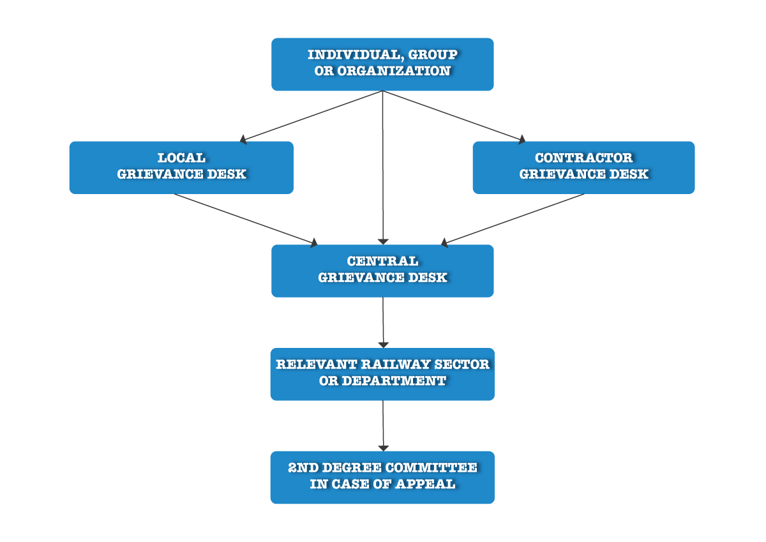

Figure 2 Organization of the Project GM

Local Grievance Desk

The local grievance in the locations where subproject activities are to be implemented. This is to ensure that complainants have easy access to GRM and that any smaller or localized grievances or requests for information can be resolved efficiently. The local grievance desk is set up either for a specific subproject, in the location where this subproject is implemented, or in a specific location, to cover all grievances related to a number of subprojects being implemented in that same location.

The local grievance desk is operated either by an employee of Serbian Railways Infrastructure working in local traffic departments responsible for local railway facilities (e.g. local train station) or a person designated by the local self-government on the territory where activities are implemented. This decision is made on an individual basis, depending on specific sub project circumstances and in cooperation between the Project and local self-governments. Once established, contact details of the person in charge of the local grievance desk (Local Grievance Manager), who is trained for the task by the PIU Central Grievance Manager, will be available all throughout the affected area and posted on the relevant websites, including the Project website and websites of local municipalities. Typical locations where GM announcements are provided include notice boards of the municipalities and any relevant local communities and train stations, but also any other locations for community gatherings such as the local culture center, health care center or pharmacy, local restaurant or shop, etc.

The most up to date list of already established local grievance desks for the Project, with contact details of grievance managers and the locations of grievance announcements is available in Chapter 6 of this document.

Contractor Grievance Desk

It is important to underline that if the Project involves any construction works at the local level, the selected contractor is also required to participate in the GM process by establishing the contractor grievance desk. This is because certain grievances relate directly to the actual construction works being performed in the field, which are under the direct responsibility of the contractor. This means that any selected contractor is obliged to designate at least one employee who is in charge of accepting and processing grievances. The contractor is obliged to inform the Project about all received grievances and how they were approached and handled. There are also situations in which grievances need to be addressed by the contractor and the PIU jointly.

Once the contractor grievance desk is established, which has to be done before any field activities take place, contact details of the person in charge of this desk (Contractor Grievance Manager) will be available alongside the contact details of the Local Grievance Manager, as well as in the location of the actual construction works (e.g. on the entrance gate of the construction site or on the construction board). The local grievance desk and the contractor grievance desk will fully cooperate in dealing with local level grievances and will ensure regular exchange of information, about project related grievances.

The most up to date list of already established contractor grievance desks for the Project, with contact details of grievance managers and the locations of grievance announcements is available in Chapter 6 of this document.

Central Grievance Desk

The central grievance desk is operated at the Project level, to ensure that more complex grievances or requests for information, which require the participation or feedback from various railway sectors and departments, are addressed.

The central grievance desk is operated by the PIU Social and Citizen Engagement Expert, also referred to as the Central Grievance Manager, who reports directly to the Head of the Project PIU, responsible for overall Project implementation. The Central Grievance Manager is in charge of collecting all grievances (resolved and unresolved) from the local and contractor grievance desks in one registry, providing support to these desks to perform their duties, monitoring their performance, responding on grievances and reporting to the PIU and WB. The Central Grievance Manager facilitates the processing of grievances, either submitted directly to the central desk or unresolved by the local/contractor desk, by engaging with all relevant railway sectors and departments and supports the work of the Second-Degree Committee deciding on grievances in an appeals process.

The contact details of the Central Grievance Manager, for submitting any questions or comments in relation to the Project are:

PIU of the Ministry of Construction, Transport, and Infrastructure
Central Grievance Desk of the Serbia Railway Sector Modernization Project
Central Grievance Manager: Ivan Radovanović
Title: Social and Citizen Engagement Expert
Address: Uzun Mirkova 3, 11000 Belgrade, Serbia
e-mail: zalbe.srsm@mgsi.gov.rs
phone number: +381 63 8412 618 (During workdays from 10h to 13h)

The above contact details are always published alongside all Local and Contractor Grievance Manager details, highlighting that direct submission to either one, or all three is allowed.

Second-Degree Appeals Committee of the Ministry

The Second-Degree Appeals Committee, established through the Decision of the Minister of Construction, Transport and Infrastructure in December 2022, comprises of three permanent and one substitute member.
The Committee meets when a complainant who is unsatisfied with the response / decision received from the grievance manager submits an appeal. The work of the Committee is facilitated by the Central Grievance Manager who is also a member of the Committee.

Processing of Grievances

A grievance is defined as any actual or perceived concern or complaint raised by a person, group or organization (complainant) in connection to the Project. The GM is designed to respond to grievances, but also to respond to any specific requests for information about the Project which may not already be available in the public domain.

Processing Steps

To effectively process a grievance or request for information, the Project implements a number of steps described below (see also Figure 3).

STEP 1: Receiving, registering and acknowledging grievances

The grievance manager (local, contractor, or central) receives a request for information or grievance (in person, by phone, post, email) and records it in the grievance log, assigning to it a specific grievance reference number. The grievance manager acknowledges receipt of a grievance within 7 working days, by contacting the complainant, through his/her preferred communication method (see 5.2 for grievances received by phone). The acknowledgement includes the description of grievance, the grievance reference number and date of receipt. In In the case, there are requests for information which can be easily and immediately addressed and do not require acknowledgement, they still need to be recorded in the grievance log.

Anonymous grievances received by email or post, from persons who do not wish to provide any of their personal or contact details, will not be answered. However, information that such a grievance has been received and how it will be processed will be available on the Project website.

STEP 2: Investigating and resolving grievances

At this stage, an investigation concerning the grievance is initiated. The complainant may be additionally contacted during this phase for further details, to provide updates and to identify possible solutions which would be acceptable to all parties.

Following the approval of the Head of the PIU and depending on the nature of the grievance, the Central Grievance Manager determines which department or person is responsible to consider and address the grievance, investigates the facts and circumstances, proposes corrective measures, and articulates an answer for the complainant. Where, after an initial investigation, it is determined that the grievance does not pertain to the Project, the procedure is terminated and the complainant is informed accordingly.

The Project is sometimes limited in investigating anonymous grievances and this is clearly articulated in grievance announcements. Nevertheless, the Project makes best efforts to address such grievances, and a response will be provided on the Project website.

STEP 3: Responding to the complainant

The grievance is dealt with, and a response is provided within 30 days of receiving the grievance. The response contains a clear assessment of the grievance/request, information that has been requested and a proposal for any corrective action if needed. The corrective action may include measures to mitigate any situations arising from the Project, and/or measures to compensate, if mitigation is not possible, with a clear timeframe within which the measures will be executed.

If the grievance desk is unable to deliver a response within 30 days, the complainant is informed in a timely manner and given a new deadline for the response. The overall period for a response cannot exceed 60 days from the time of receiving the grievance, although the time period for implementing any corrective measures may need to be longer, depending on the nature of the grievance

Responses to anonymous grievances are provided on the Project website and the address of the Project website is published on all grievance notices.

STEP 4: Closing out grievances in the first degree

If the complainant is satisfied with the first-degree response / decision received from the grievance desk, the grievance is closed. For any complex grievances and grievances requiring action, the grievance manager will request from the complainant to provide a signed confirmation that the grievance has been adequately addressed and is considered closed.

STEP 5: Addressing appeals

If the complainant is not satisfied with the first-degree response / decision, he/she has the right to appeal to the Second-Degree Committee of the Ministry, by informing the Central Grievance Manager. This is clearly stated in every response provided to the complainant, as well as information that the Central Grievance Manager will assist the complainant in preparing and submitting the appeal to the Second-Degree Committee.
Upon receiving an appeal, the Central Grievance Manager schedules a session of the Second-Degree Committee and presents the grievance case for review. Dedicated meetings between the Second-Degree Committee and the complainant are sometimes necessary and may involve representatives of the relevant local self-government or other local stakeholders, with the aim of identifying a solution to the grievance, acceptable to all parties.

The response to an appeal is provided within 30 days of receiving the appeal, however in case of any delays in organizing the relevant meetings or obtaining the relevant information, the complainant is kept regularly updated by the Central Grievance Manager.

STEP 6: Closing out appeals

The process of closing out appeals is the same as for first degree decisions, with a request for confirmation from the complainant. If the complainant is not satisfied and will not confirm that the grievance is satisfactorily closed, he/she is advised of the option to seek resolution from the competent court.
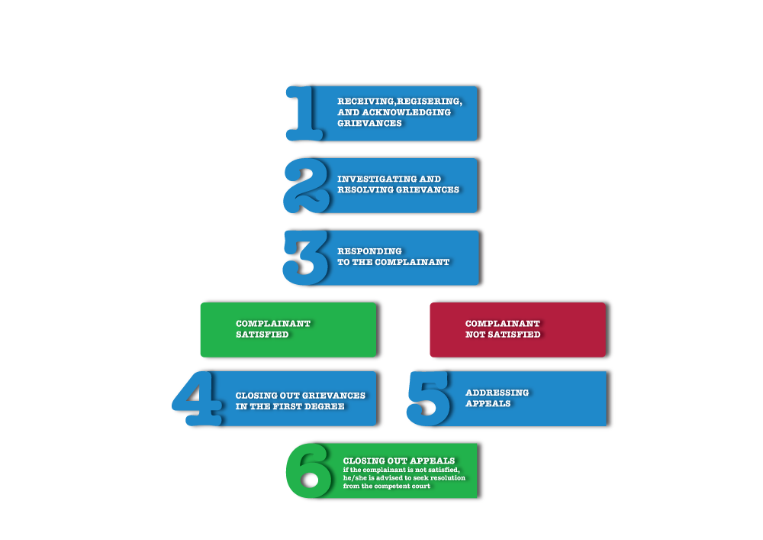

Figure 3 Steps for processing grievances

Phone Grievances

When grievances are received by phone, the grievance managers record details of the call in the grievance log, particularly the date when the call was made, the nature of the conversation and any other facts of significance. The grievance manager always attempts to agree with the complainant on how a written response can be provided to him/her (by email or post), to serve as a record of the process and outcome. If this is not possible, the record of the phone exchange made by the grievance manager in the grievance log, serves this purpose.

Local and Contractor Grievance Desk Details

The table below is regularly updated in this document by the Central Grievance Manager, as relevant information becomes available.

Sub Project / Territory | Locations of GM announcements | Contact details for Local Grievance Manager | Contact details for Contractor Grievance Manager

Submitting a Grievance

Any person who has a question or complaint in relation to the Serbia Railway Sector Modernization Project, should fill out the grievance form provided as ANNEX 1, or use it as guidance for preparing his/her submission. The grievance or question can be submitted by post or e-mail using the following contact details:

PIU of the Ministry of Construction, Transport, and Infrastructure
Central Grievance Desk of the Serbia Railway Sector Modernization Project
Attn. Central Grievance Manager: Ivan Radovanović, Social and Citizen Engagement Expert
Address: Uzun Mirkova 3, 11000 Belgrade, Serbia
e-mail: zalbe.srsm@mgsi.gov.rs
phone number: +381 63 8412 618 (During workdays from 10h to 13h)

World Bank Grievance Redress Service

Communities and individuals who believe that they are adversely affected by a World Bank (WB) supported project may submit complaints to existing project-level grievance redress mechanisms or the WB’s Grievance Redress Service (GRS). The GRS ensures that complaints received are promptly reviewed in order to address project-related concerns. Project affected communities and individuals may submit their complaint to the WB’s independent Inspection Panel which determines whether harm occurred, or could occur, as a result of WB non-compliance with its policies and procedures. Complaints may be submitted at any time after concerns have been brought directly to the World Bank’s attention, and Bank Management has been given an opportunity to respond. For information on how to submit complaints to the World Bank’s corporate Grievance Redress Service (GRS), please visit:

http://www.worldbank.org/en/projects-operations/products-and-services/grievance-redress-service

MONITORING AND REPORTING

Monitoring reports documenting the environmental and social performance of the Project will be prepared by the PIU and submitted to the World Bank quarterly as part of the overall progress reporting requirements as set forth in the Loan Agreement (to be signed). These reports will include a section regarding stakeholder engagement and grievance management.

Table 8 proposes a comprehensive set of indicators related to stakeholder engagement performance at this stage. The achievement of indicators shall rely on information from the SEL and the Grievance Log.

Table 8: Monitoring indicators

Indicator | How will it be monitored | Responsibility | Frequency
Engagement with affected parties
Number and location of formal meetings | Minutes of Meetings | PIU’s Social Specialist | Quarterly
Number and location of informal/ spontaneous meetings | Minutes of Meetings | PIU’s Social Specialist | Quarterly
Number and location of community awareness raising or training meetings | Minutes of Meetings | PIU’s Social Specialist | Quarterly
Number of men and women that attended each of the meetings above | List of Attendees | PIU’s Social Specialist | Quarterly
For each meeting, number and nature of comments received, actions agreed during these meetings, status of those actions, and how the comments were included in the Project environmental and social management system | Minutes of Meetings | PIU’s Social Specialist | Quarterly
Engagement with other stakeholders
Number and nature of engagement activities with other stakeholders, disaggregated by category of stakeholder (Governmental departments, municipalities, NGOs) | Minutes of Meetings | PIU’s Social Specialist | Quarterly
Grievance Resolution Mechanism
Number of grievances received, in total and at the local level, on the website, disaggregated by complainant’s gender and means of receipt (telephone, email, discussion) | Grievance Log | PIU’s Social Specialist,  Grievance Focal Point | Quarterly
Number of grievances received from affected people, external stakeholders | Grievance Log | PIU’s Social Specialist,  Grievance Focal Point | Quarterly
Number of grievances which have been (i) opened, (ii) opened for more than 30 days, (iii) those which have been resolved, (iv) closed, and (v) number of responses that satisfied the complainants, during the reporting period disaggregated by category of grievance, gender, age and location of complainant. | Grievance Log | PIU’s Social Specialist,  Grievance Focal Point | Quarterly
Average time of complaint’s resolution process, disaggregated by gender of complainants and categories of complaints | Grievance Log | PIU’s Social Specialist,  Grievance Focal Point | Quarterly
Number of LGD meetings, and outputs of these meetings | Minutes of meetings signed by the attendees | PIU’s Social Specialist,  Grievance Focal Point | Quarterly
Trends in time and comparison of number, categories, and location of complaints with previous reporting periods | Grievance Log | PIU’s Social Specialist,  Grievance Focal Point | Quarterly

Note: Minutes of meetings of formal meetings and summary note of informal meetings will be annexed to the quarterly report. They will summarize the view of attendees and distinguish between comments raised by men and women.

Reporting back to stakeholder groups

The sub-project specific SEPs, after having had developed, will be periodically updated as necessary in the course of project implementation in order to ensure that the information presented herein is consistent and is the most recent, and that the identified methods of engagement remain appropriate and effective in relation to the project context and specific phases of the development. This in particular will be the case if COVID-19 recalibrating of engagement methods is necessary. Any major changes to the project related activities and to its schedule will also constitute a change calling for reflection in the SEPs.

Periodic summaries and internal reports on public grievances, enquiries and related incidents, together with the status of implementation of associated corrective/preventative actions will be collated by responsible staff and referred to the senior management of the project. The summaries will provide a mechanism for assessing both the number and the nature of complaints and requests for information, along with the Project’s ability to address those in a timely and effective manner. Information on public engagement activities undertaken by the Project during the year may be conveyed to the stakeholders in two possible ways:

- Publication of a standalone annual report on project’s interaction with the stakeholders.
- Adopt software solutions to scale up the two-way interaction and feedback, by using survey platforms, preferable using one dashboard to make it easy to measure and understand the feedback (any platform in use and central governmental MCTI level, or alternatively /in addition (as required) SurveyMonkey or alternative online platform can be applied), in order to meet citizens’ expectations for change created by their engagement, use their input to facilitate improved development outcomes;
- Monitoring of a beneficiary feedback indicator on a regular basis. The indicators may include: number of consultations, including by using telecommunications carried out within a reporting period (e.g. monthly, quarterly, or annually); number of grievances received within a reporting period (e.g. monthly, quarterly, or annually) and number of those resolved within the prescribed timeline; number of press materials published/broadcasted in the local, regional, and national media.
Refinement of the stakeholder feedback methods will be outlined in the sub-project specific SEPs.

REPORT ON PUBLIC DISCLOSURE AND PUBLIC CONSULTATION

As required by WB Environmental and Social Standard 10 (ESS10) – Stakeholder Engagement and Information disclosure, during preparation of Draft ESMF SEP, LMP and RPF documents the Borrower carried out public consultations with relevant stakeholders.

The documents are available to the public on the Ministry website (on the following link: https://www.mgsi.gov.rs/cir/aktuelnosti/javne-rasprave) since August 24th, and they will be available throughout the entire duration of the Project. The public also had the possibility to view the documents in person, in the office of the PIU in Uzun Mirkova 3, in Belgrade. The invitation was published on the website of the Ministry of Construction, Traffic and Infrastructure, as well as a daily newspaper with national coverage “Politika”. Public and other interested parties and organizations were invited to participate in process of public consultation on draft documents. The public and other interested parties could send their comments and questions about the documents until September 11th, 2023, by post (Uzun Mirkova 3), or by e-mail (same e-mail address used for the project grievance mechanism zalbe.srsm@mgsi.gov.rs). No comments have been issued on the documents.

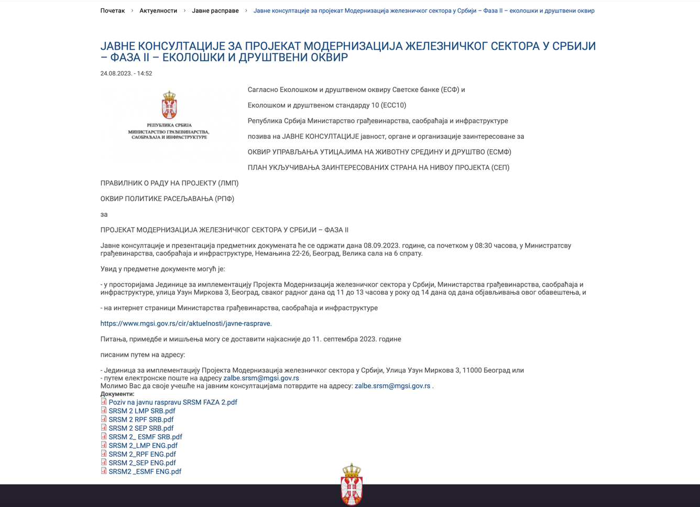

Image 1: Announcement of public consultation on the MCTI website

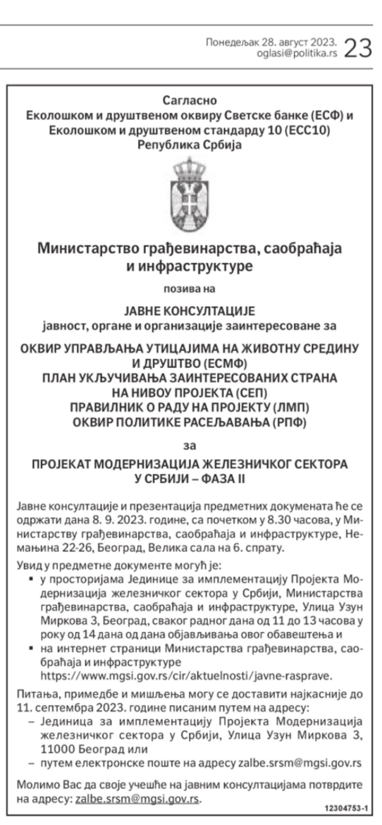

Image 2: Announcement of public consultation in daily newspaper, (“Politika”, August 28th, 2023)

On Friday, September 8th, 2023, at 8:30h the PIU organized public consultation and presentation of the E&S documents on the Phase 2 of the Serbia Railway Sector Modernization project. The consultation took place in the Ministry of Construction, Traffic and Infrastructure, Nemanjina 22-26, 6th floor, “Big Conference Room”. More than 18 people were present, as some did not sign the attendance sheet. As per the attendance sheet, 18 people were present, out of which 9 women, from the PIU, MCTI, Srbija Voz, Infrastruktura Železnice Srbije, Srbija Cargo, and Railway Directorate. Some parts of the attendance sheet will be redacted in this document due to the restrictions of the Law on the protection of personal data, but the complete sheet is available for internal use in the office of the PIU.

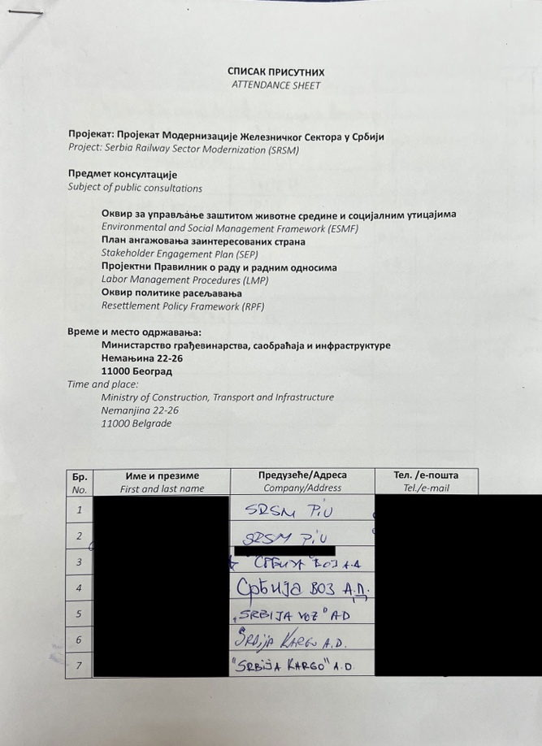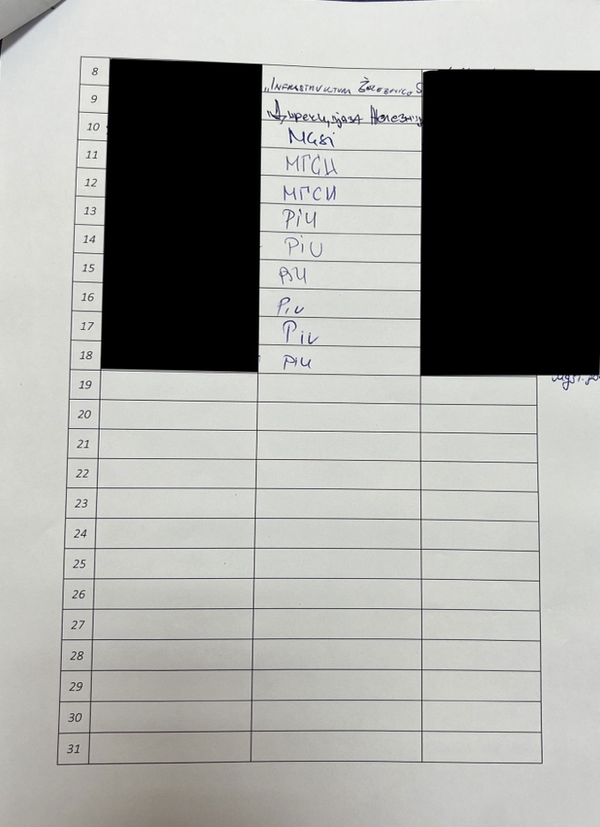

Image 3: Attendance sheet, with personal and contact information redacted.

The consultation started with the opening speech by Anita Dimoski, the acting assistant minister for railway and intermodal transport, and Larisa Puzović, the head of the PIU. Nikola Adžić, the civil engineer of the PIU started the presentation explaining the multi-phase approach and the project components. Nebojša Pokimica, the PIU environmental expert presented the ESMF, and Ivan Radovanović, the PIU social and citizen engagement specialist presented SEP, LMP and RPF. At the end, all the attendees could see the final screen with the contact details and ways to send their questions and opinions, and were invited once again to share their opinions in person, during the public consultation. Nobody had comments.
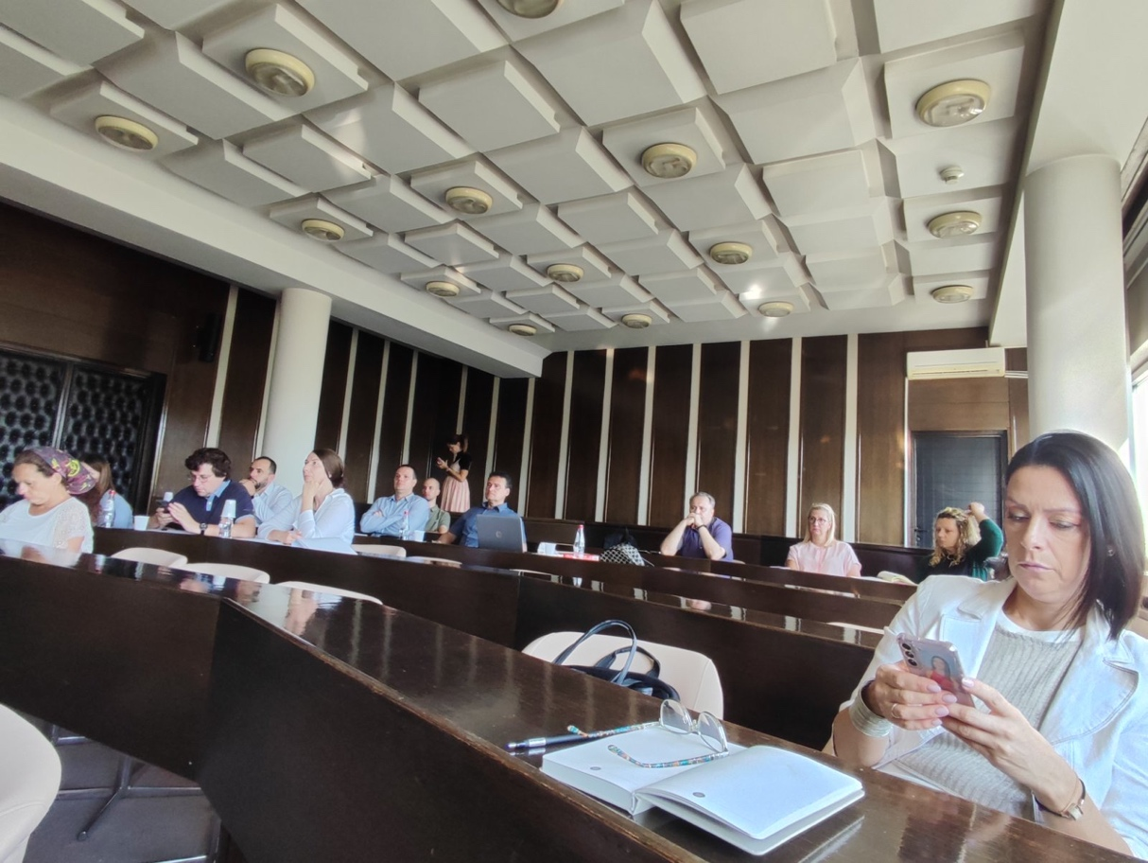

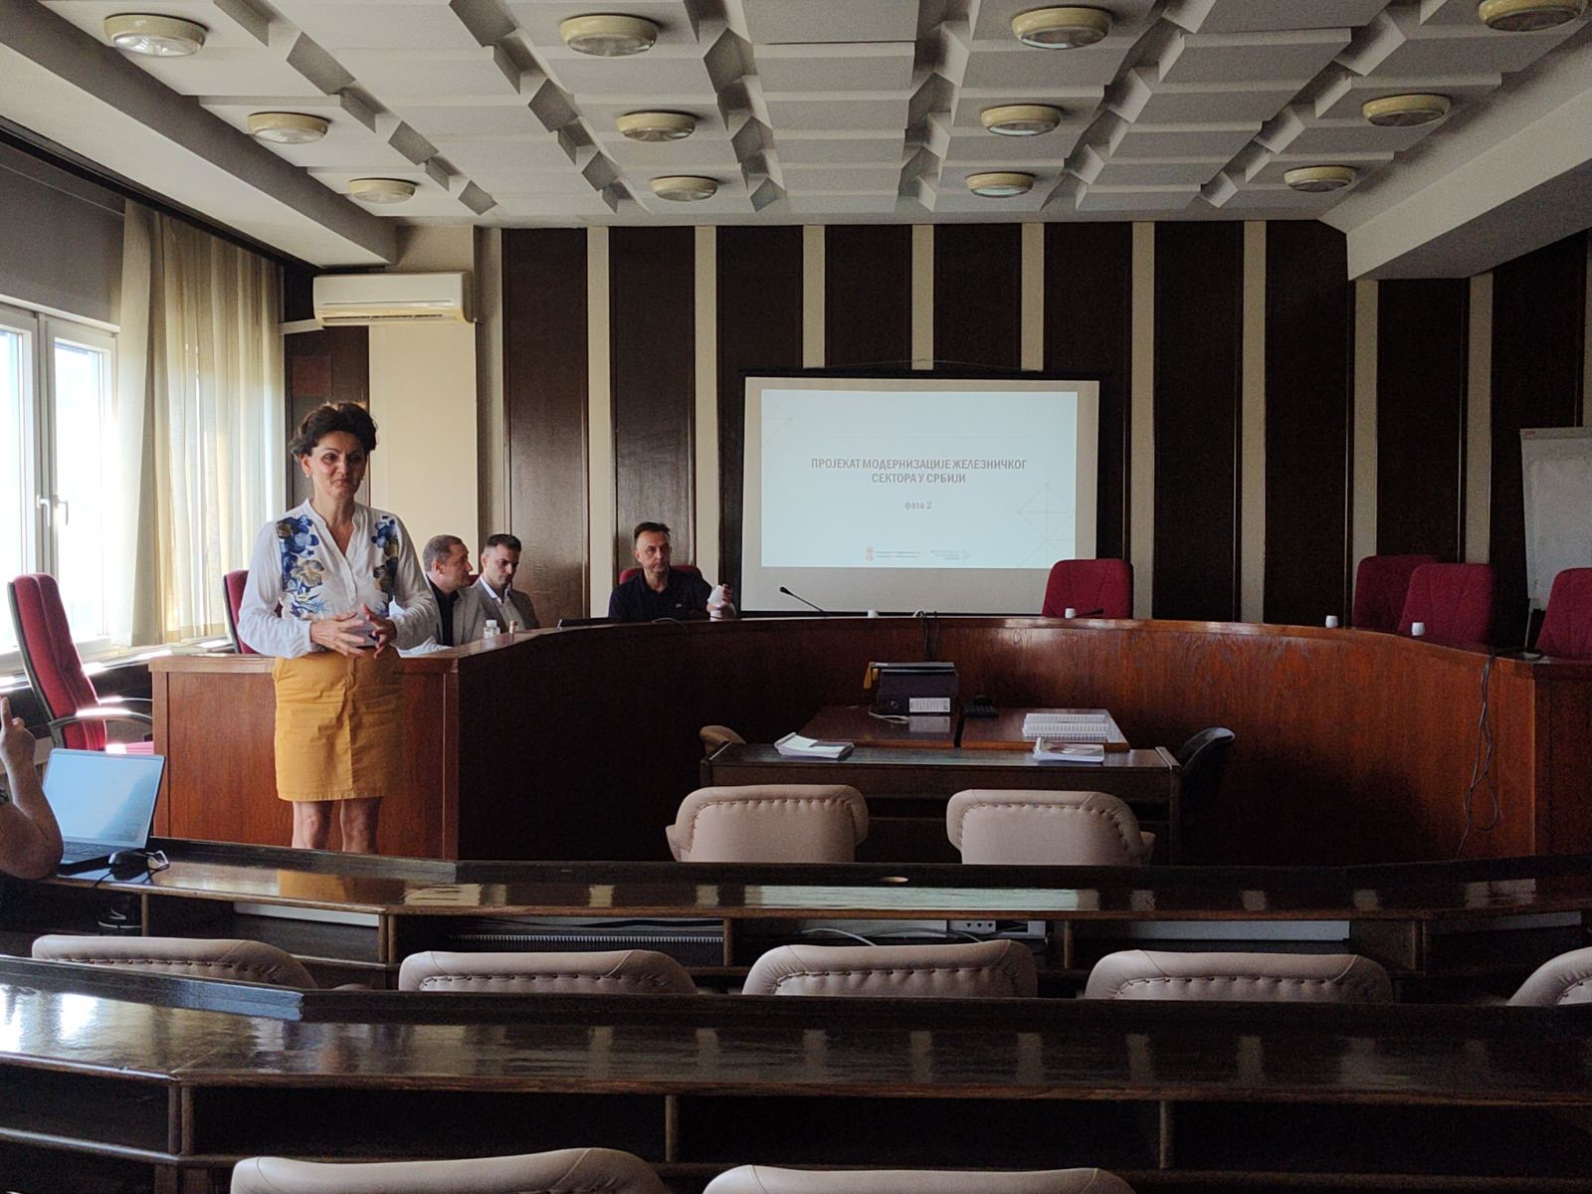

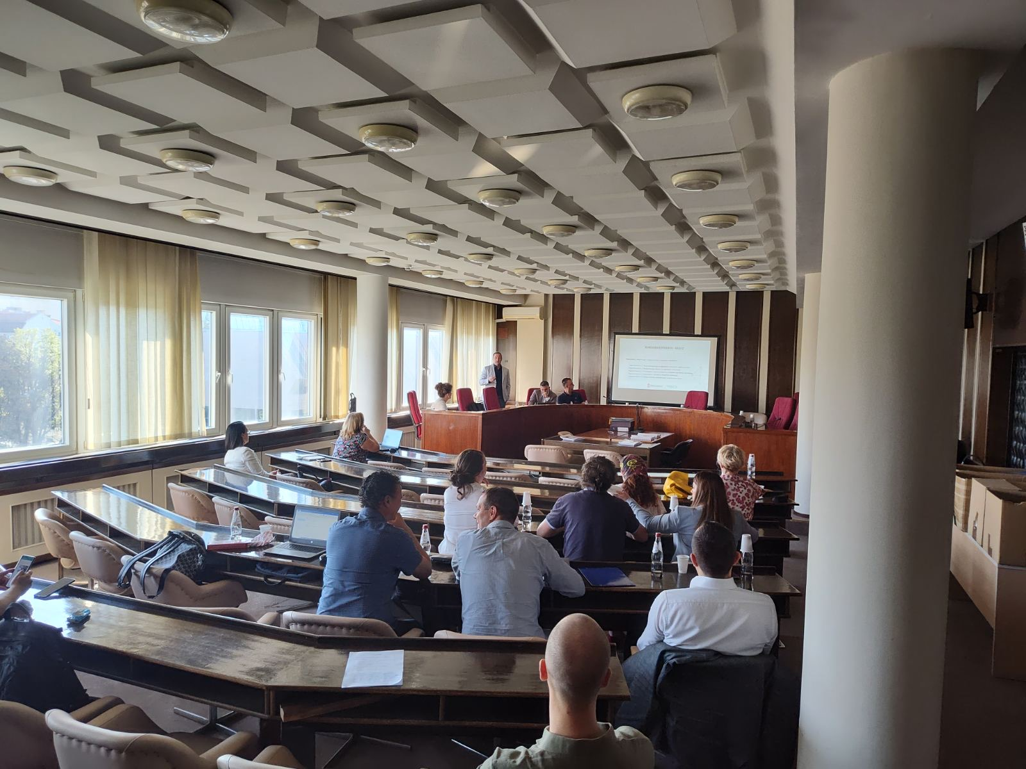

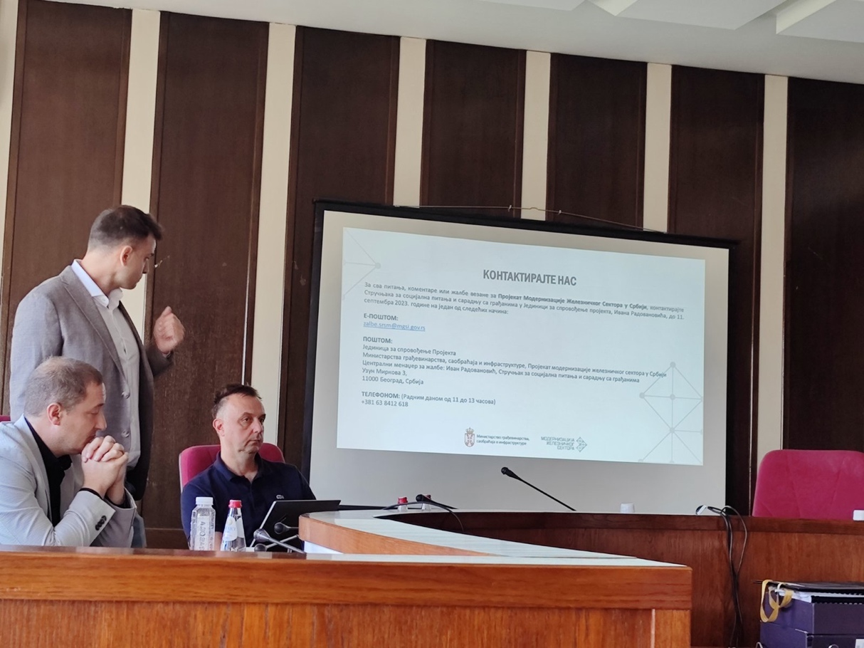

The ESF is accessible at - https://www.worldbank.org/en/projects-operations/environmental-and-social-framework. Lates accessed on July 21, 2020
From 02.12.2022.; No. 340-01-00371/2022-04

